**GIT ASSIGNMENT**

SECTION-0

1.Create A directory ‘project_dir’ & cd to ‘project_dir’.

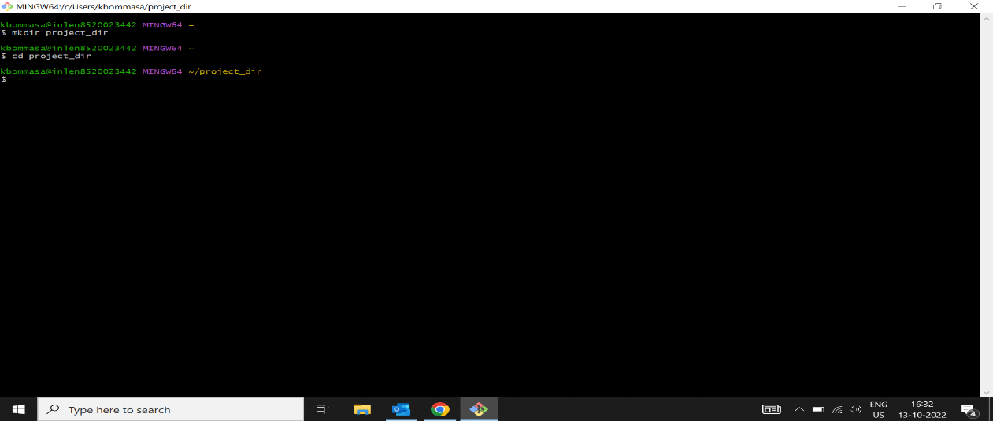

2.Initialize Git version database

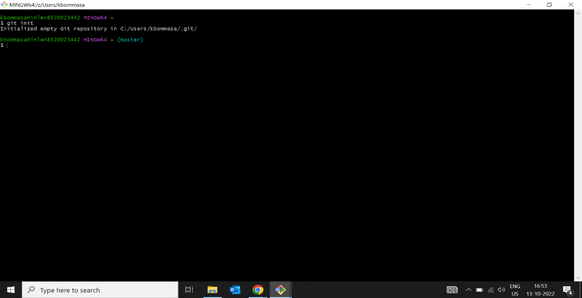

3.create a new file index.html

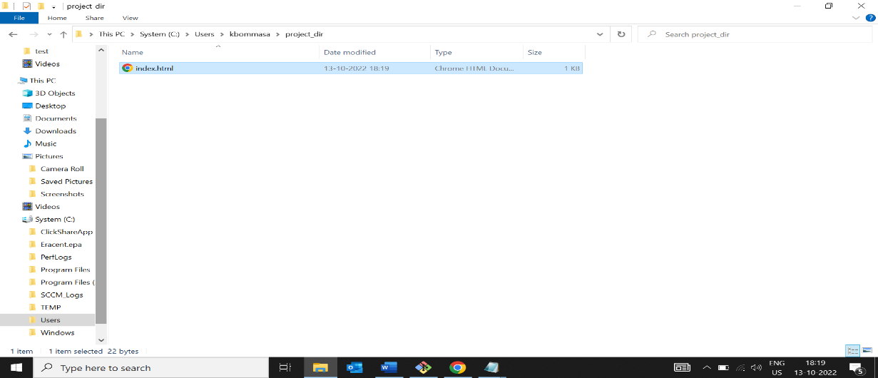

4.Check the git status. You should find index.html as untracked file.

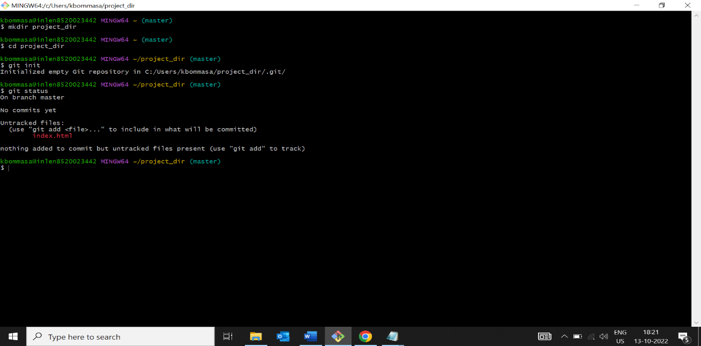

5.Stage the index.html file

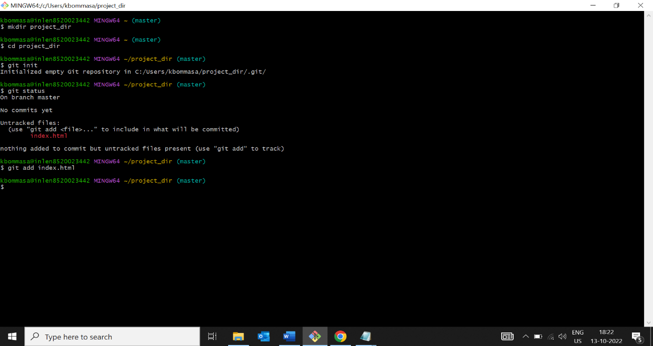

6.commit the index.html

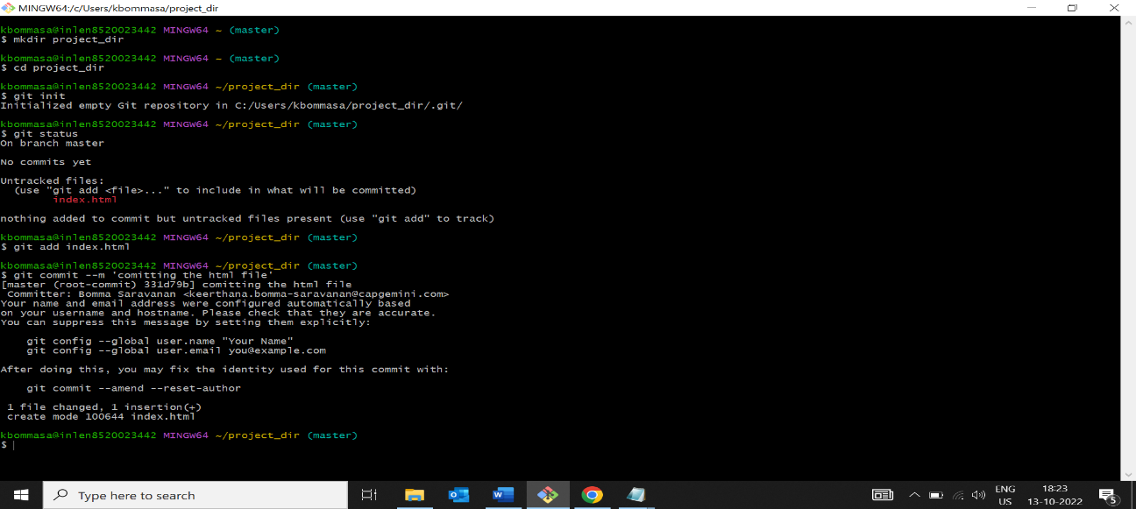

7.Make few changes in index.html file and create a new file info.txt file

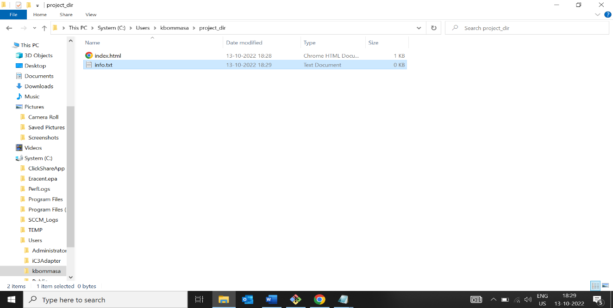

8.Check git status. You should find info.txt and index.html as untracked files

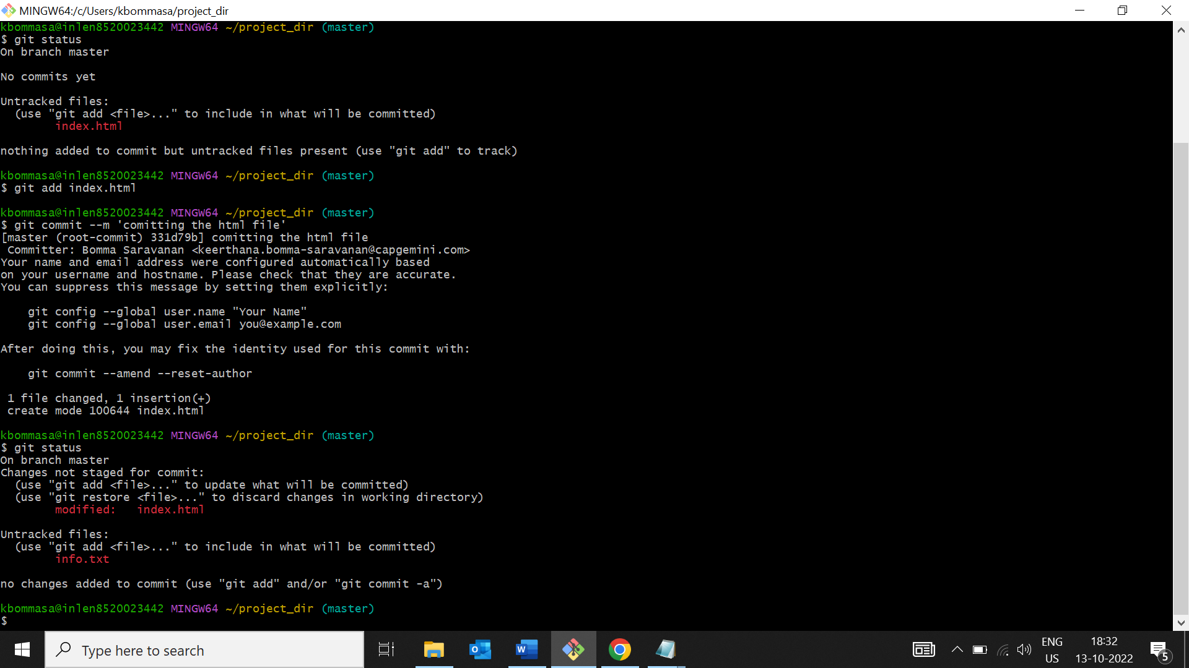

9.Configure GIT to ignore all txt files

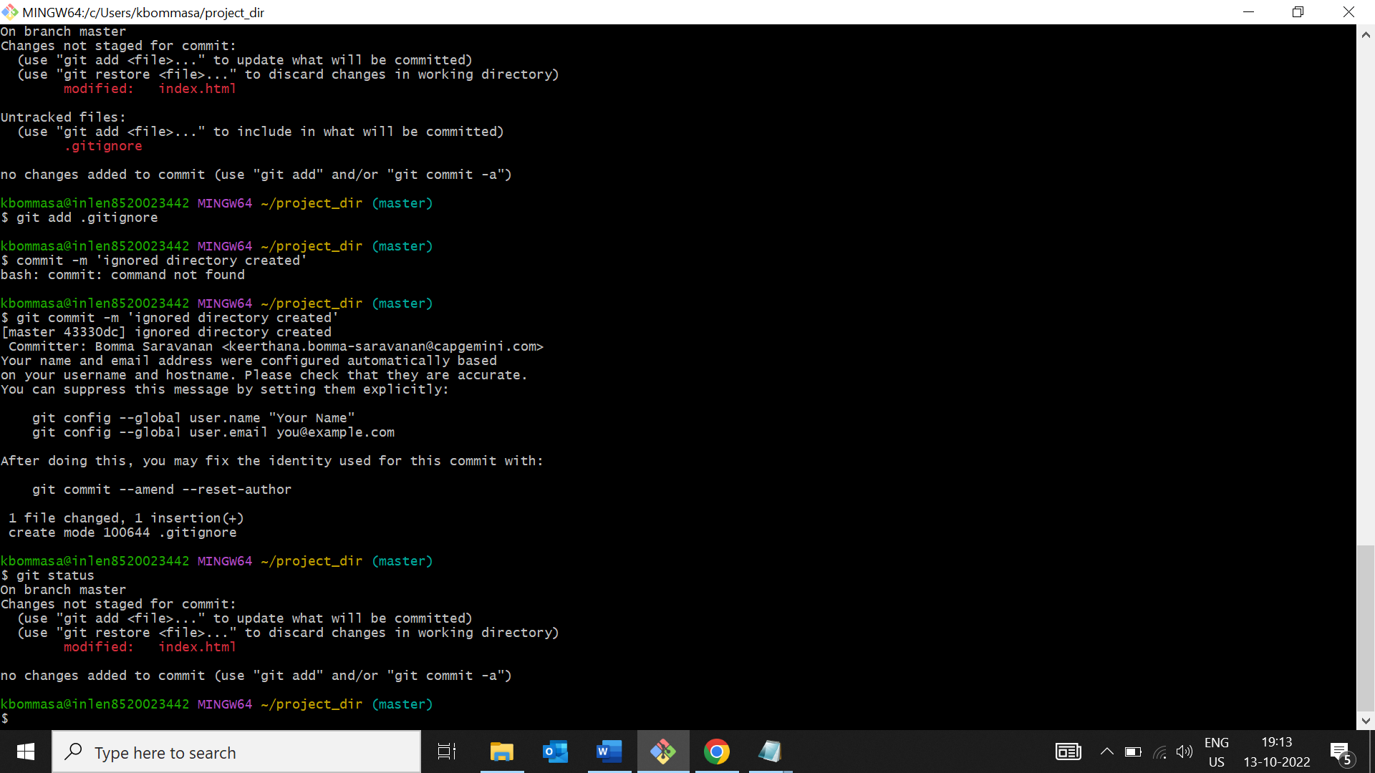

10.Again check the git status. You should find only Index.html as untracked file.



11.State and commit index.html

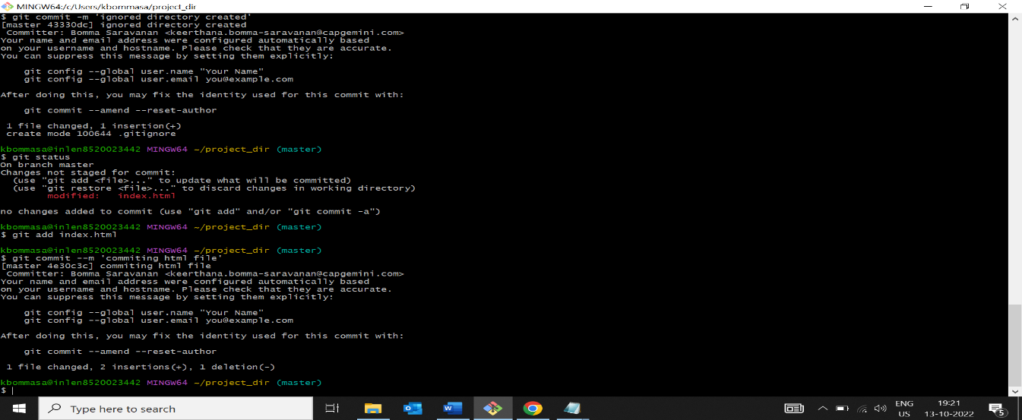

12.Log all your comments so far.

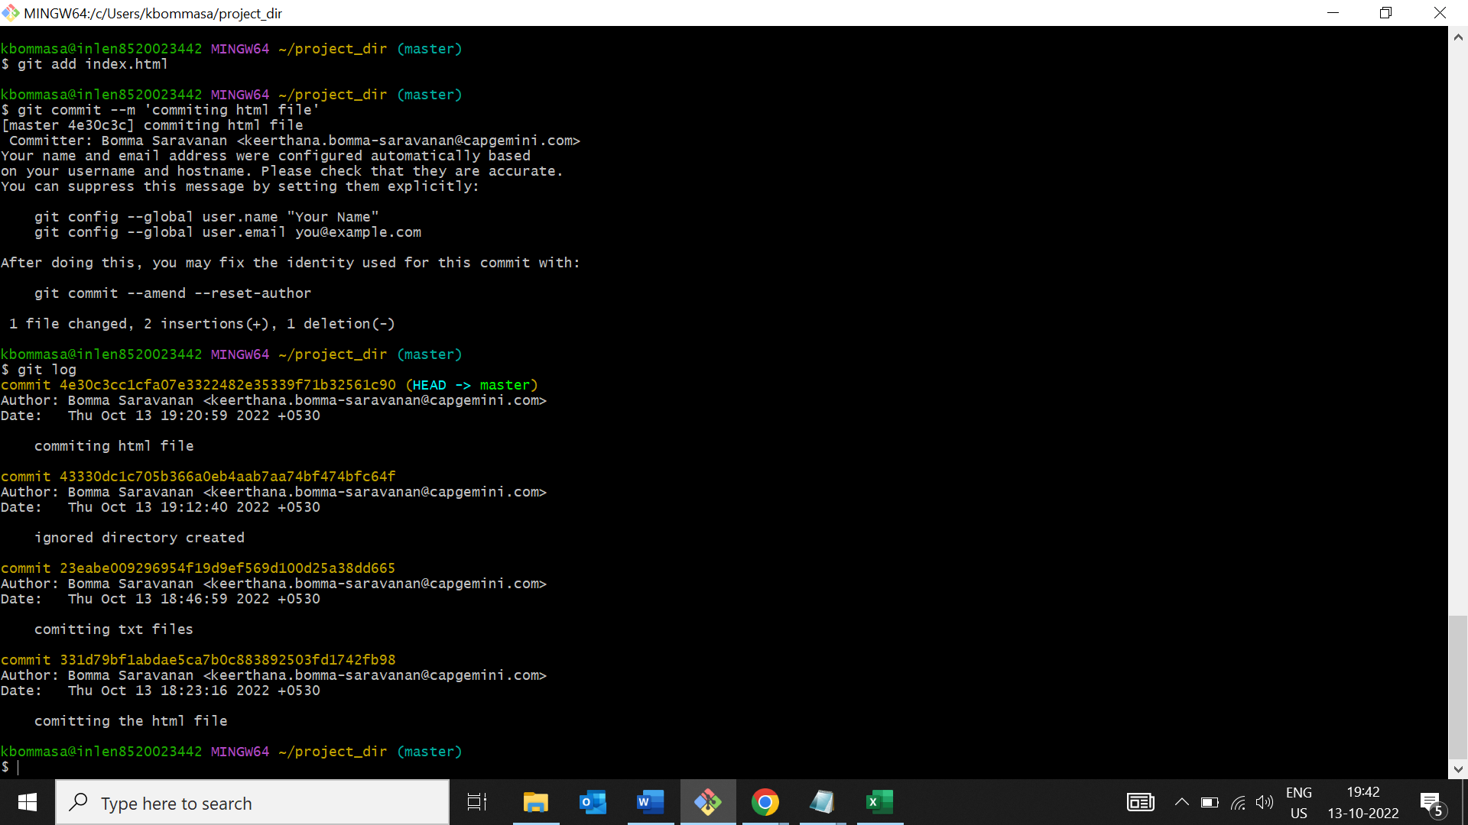

13.Make some changes in index.html

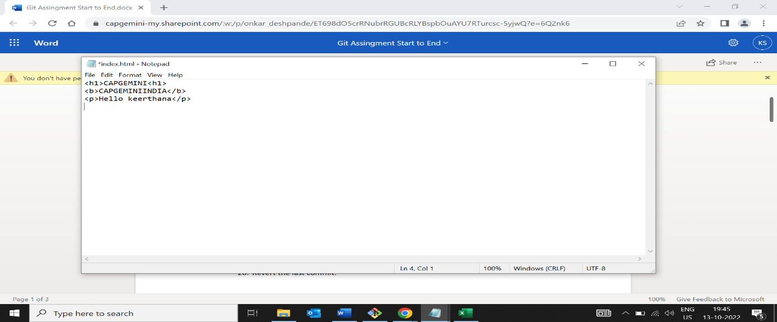

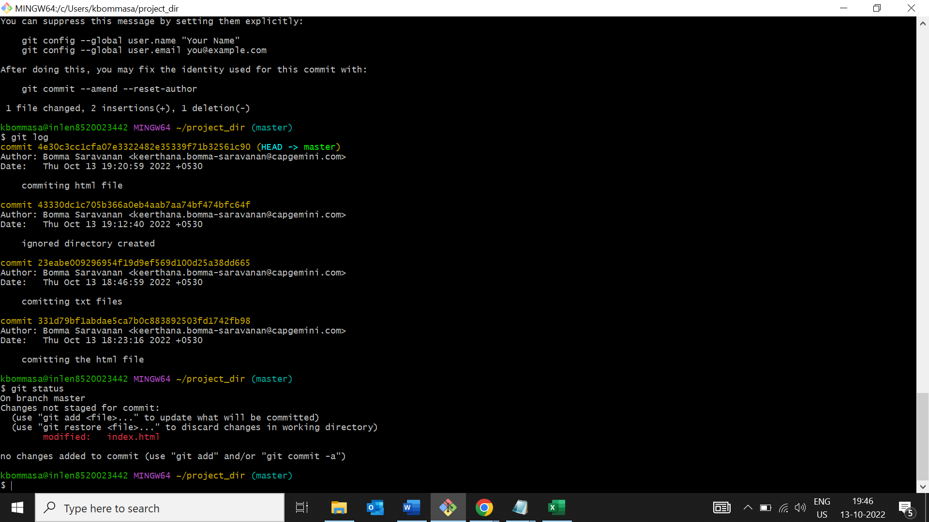

14.Revert the change made in the previous step using git command

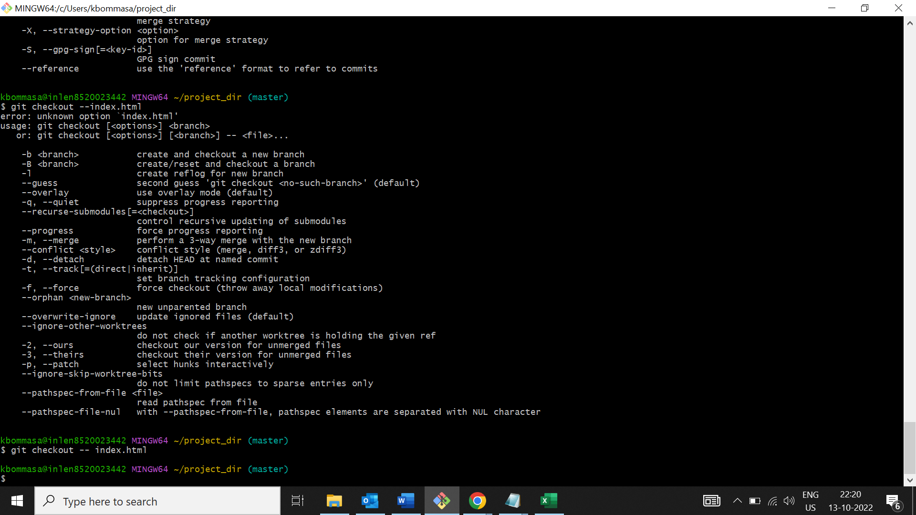

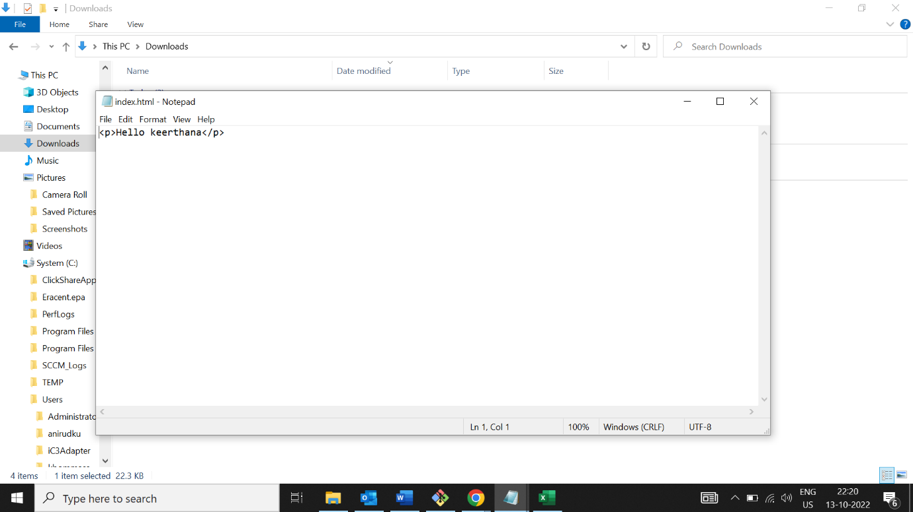

15.Again change index.html

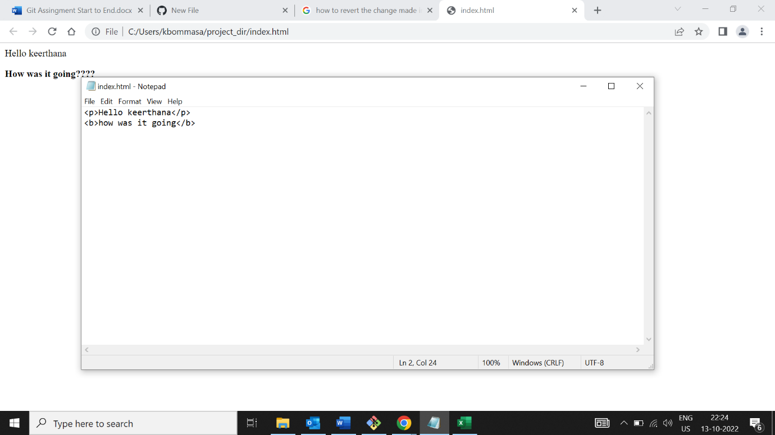

16.Stage index.html

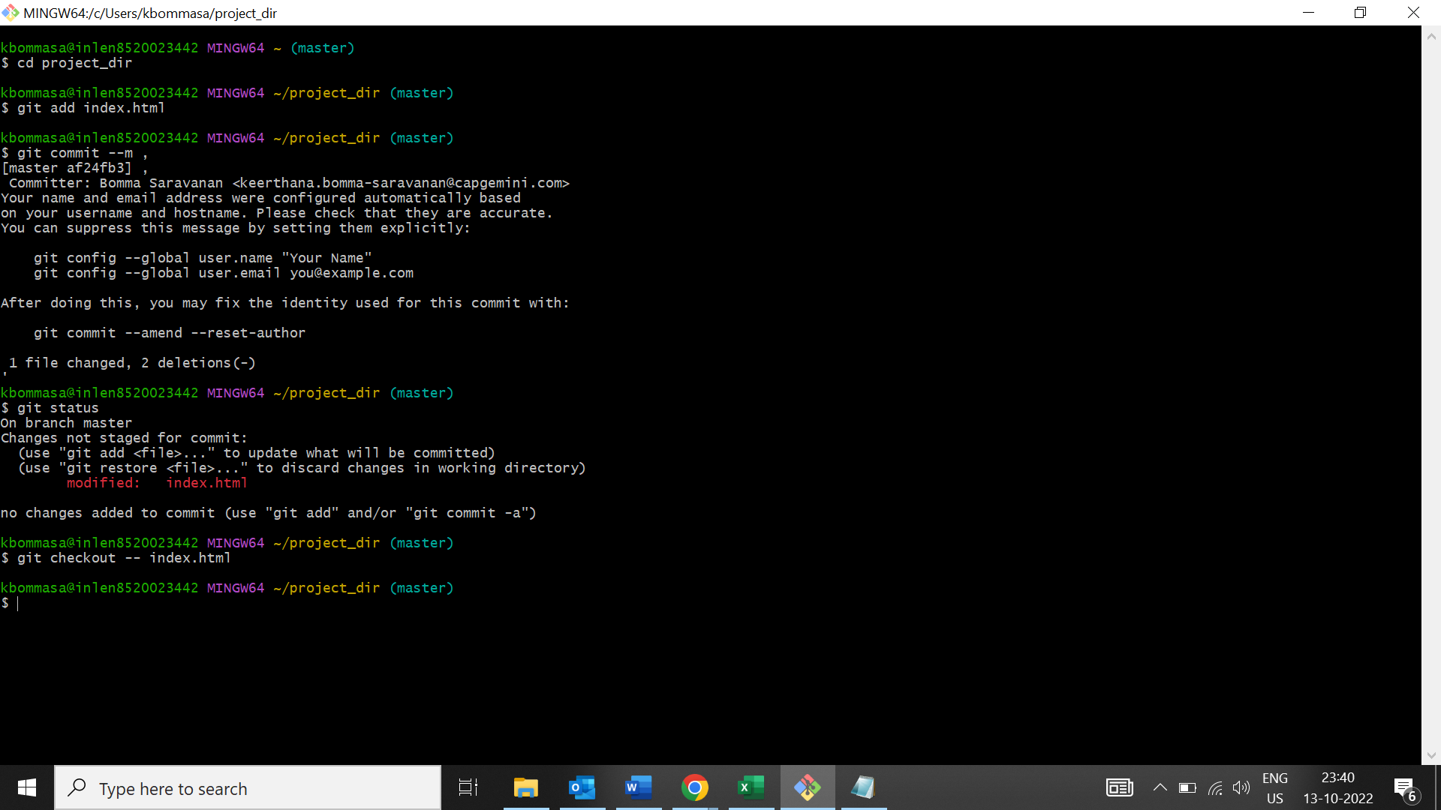

17.Revert back the last stage.

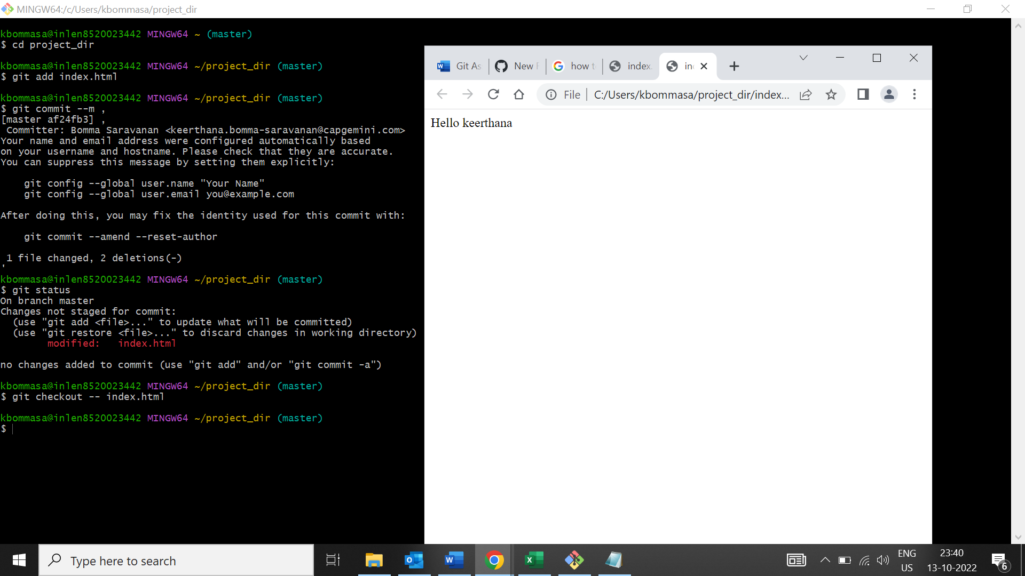

18.Rename add command to my-add.

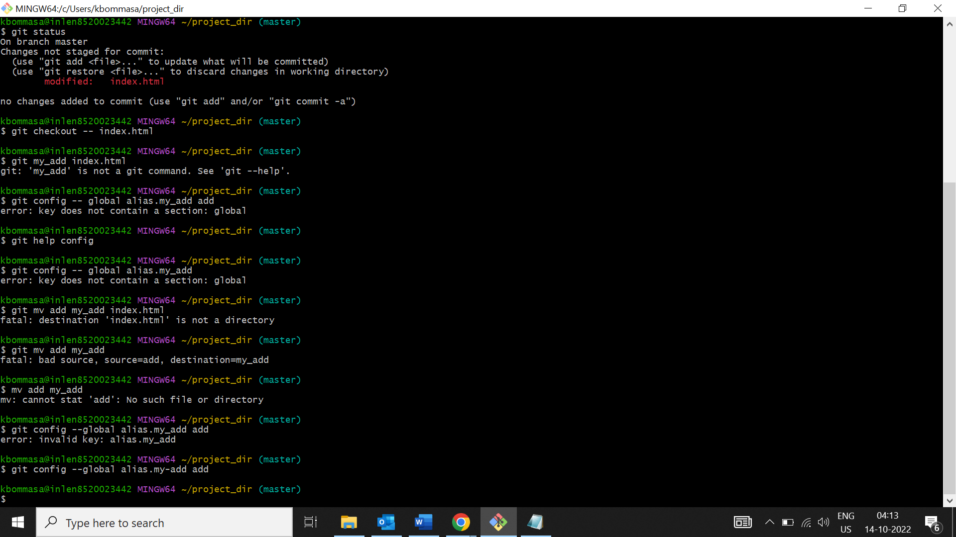19.Using my-add command stage index.html again and commit the changes.

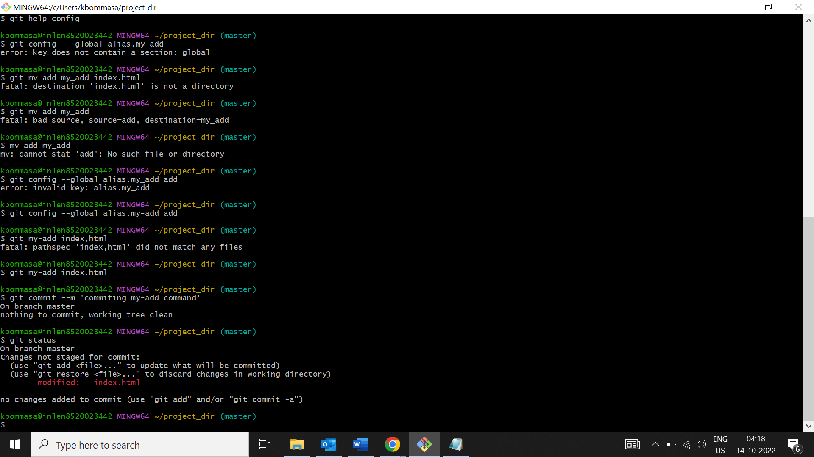

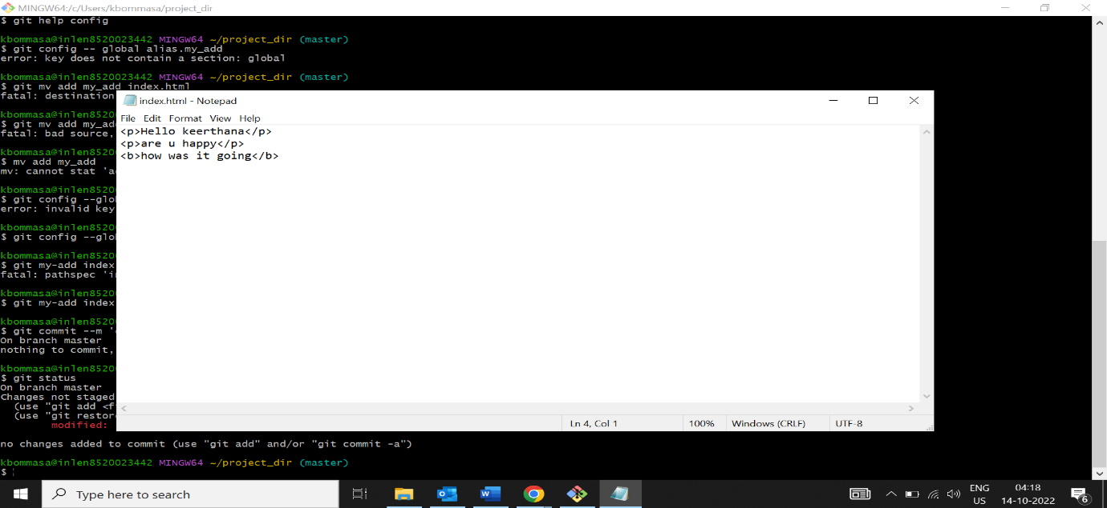

20.Revert the last commit.

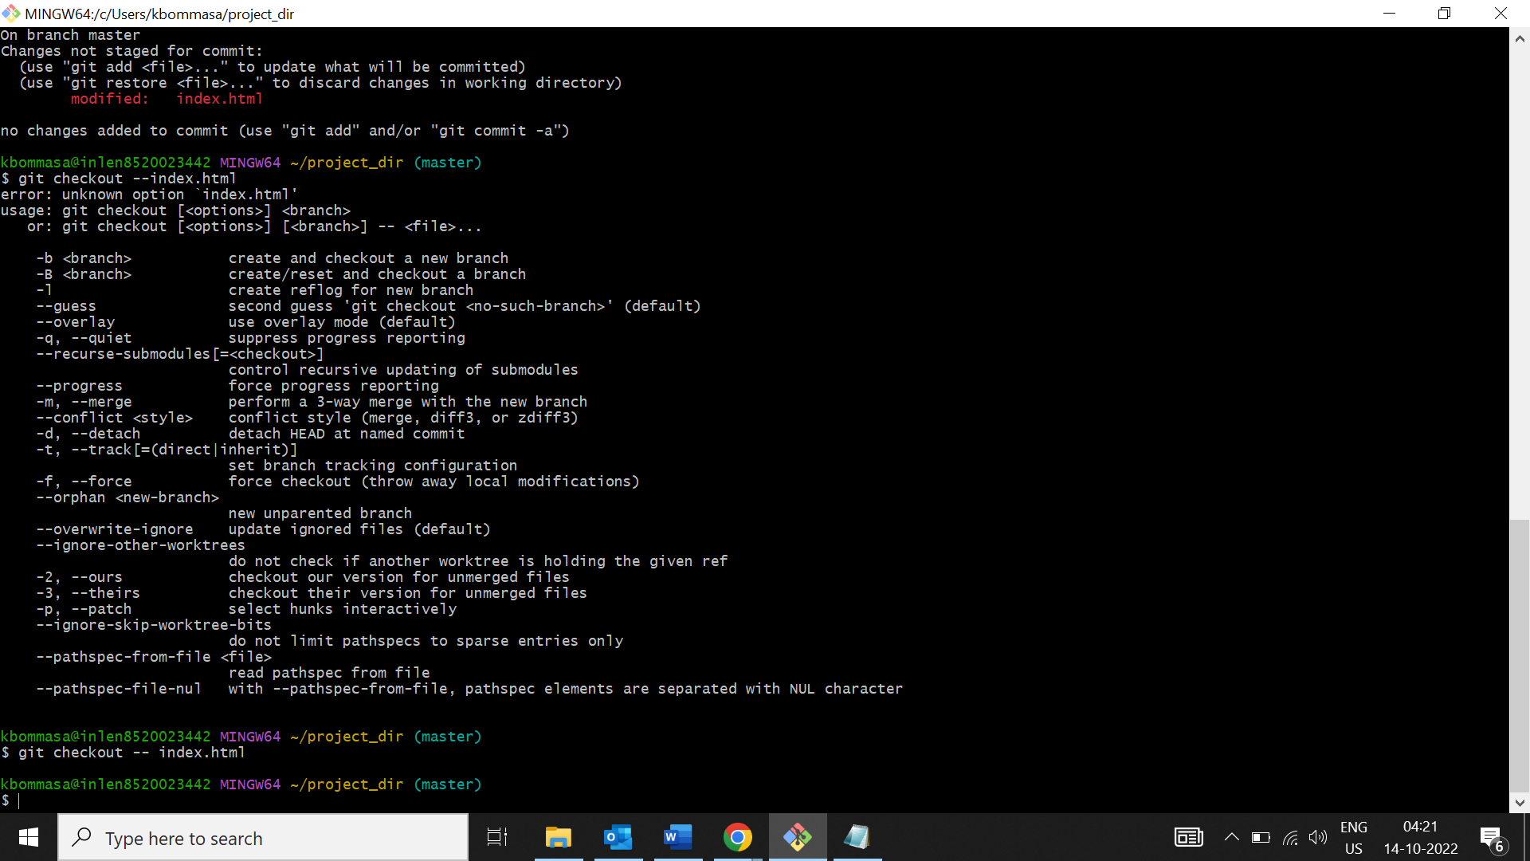

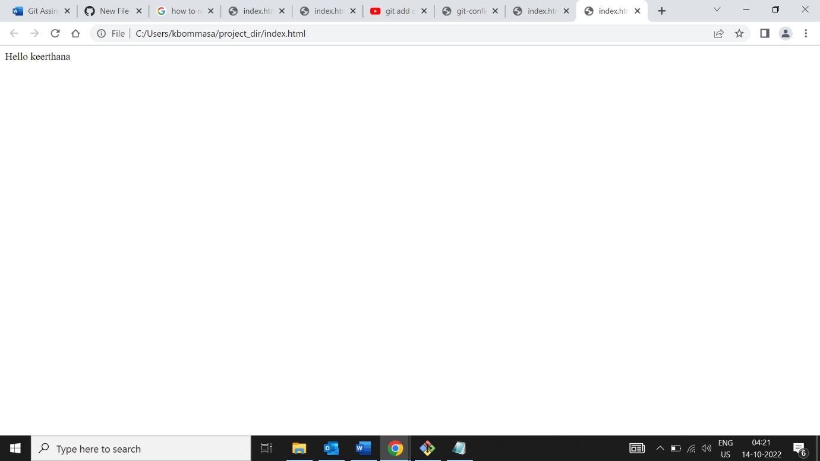

**SECTION-1 GIT BRANCHING**

22.Create an empty directory ‘Assignments’ and cd to ‘assignments’

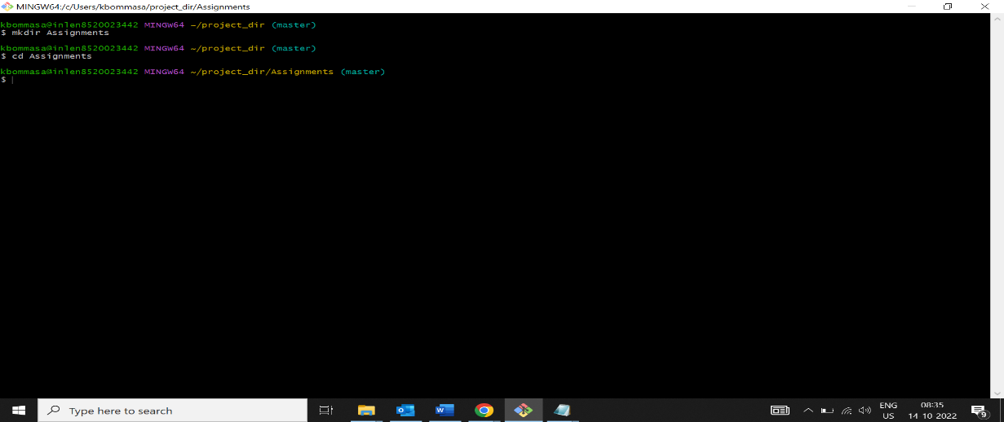

23.Create README.txt and inside ‘Assignments’ and write few lines about contents of Assignment folder.

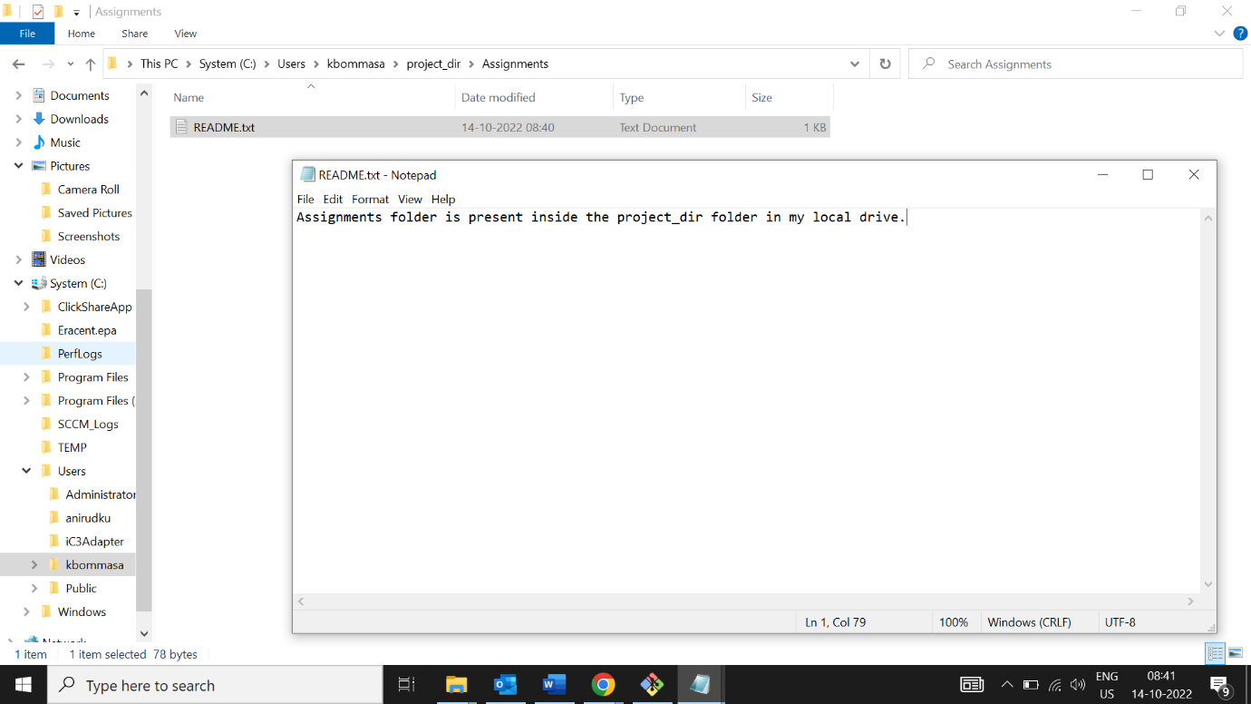

24.Commit README text file.

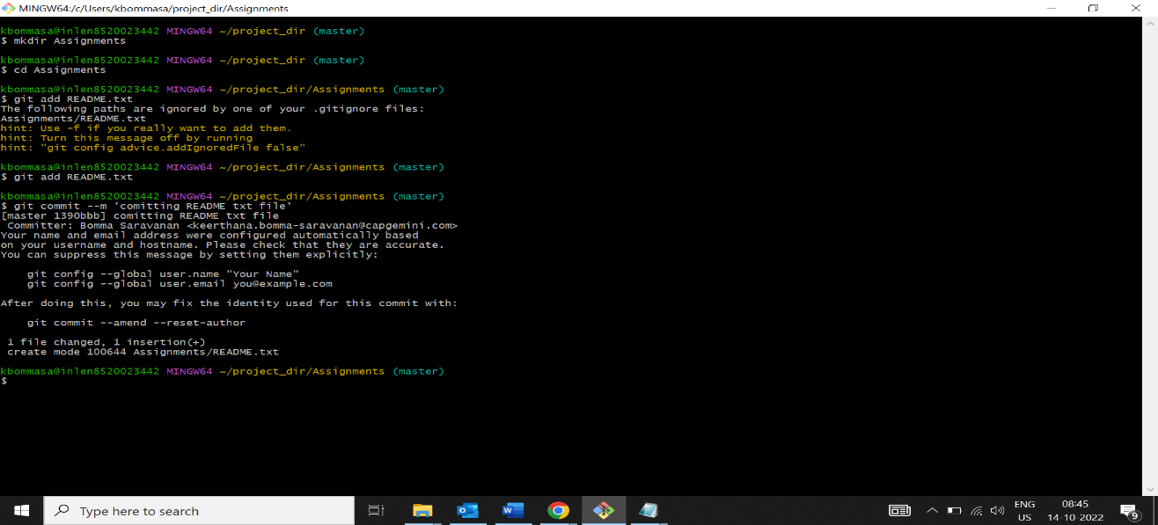

25.Now create a new branch ‘html-assignments’

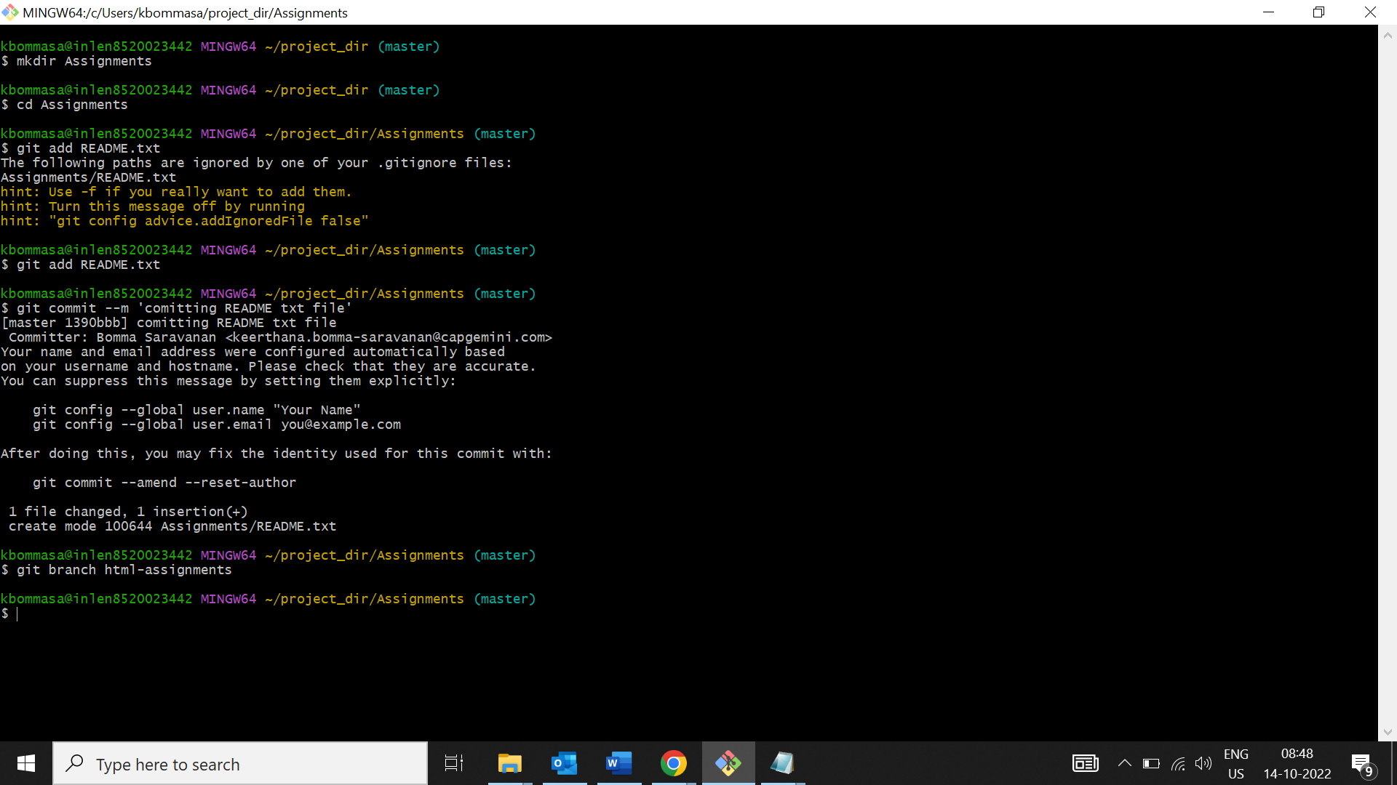

26.Switch to html-assignments branch.

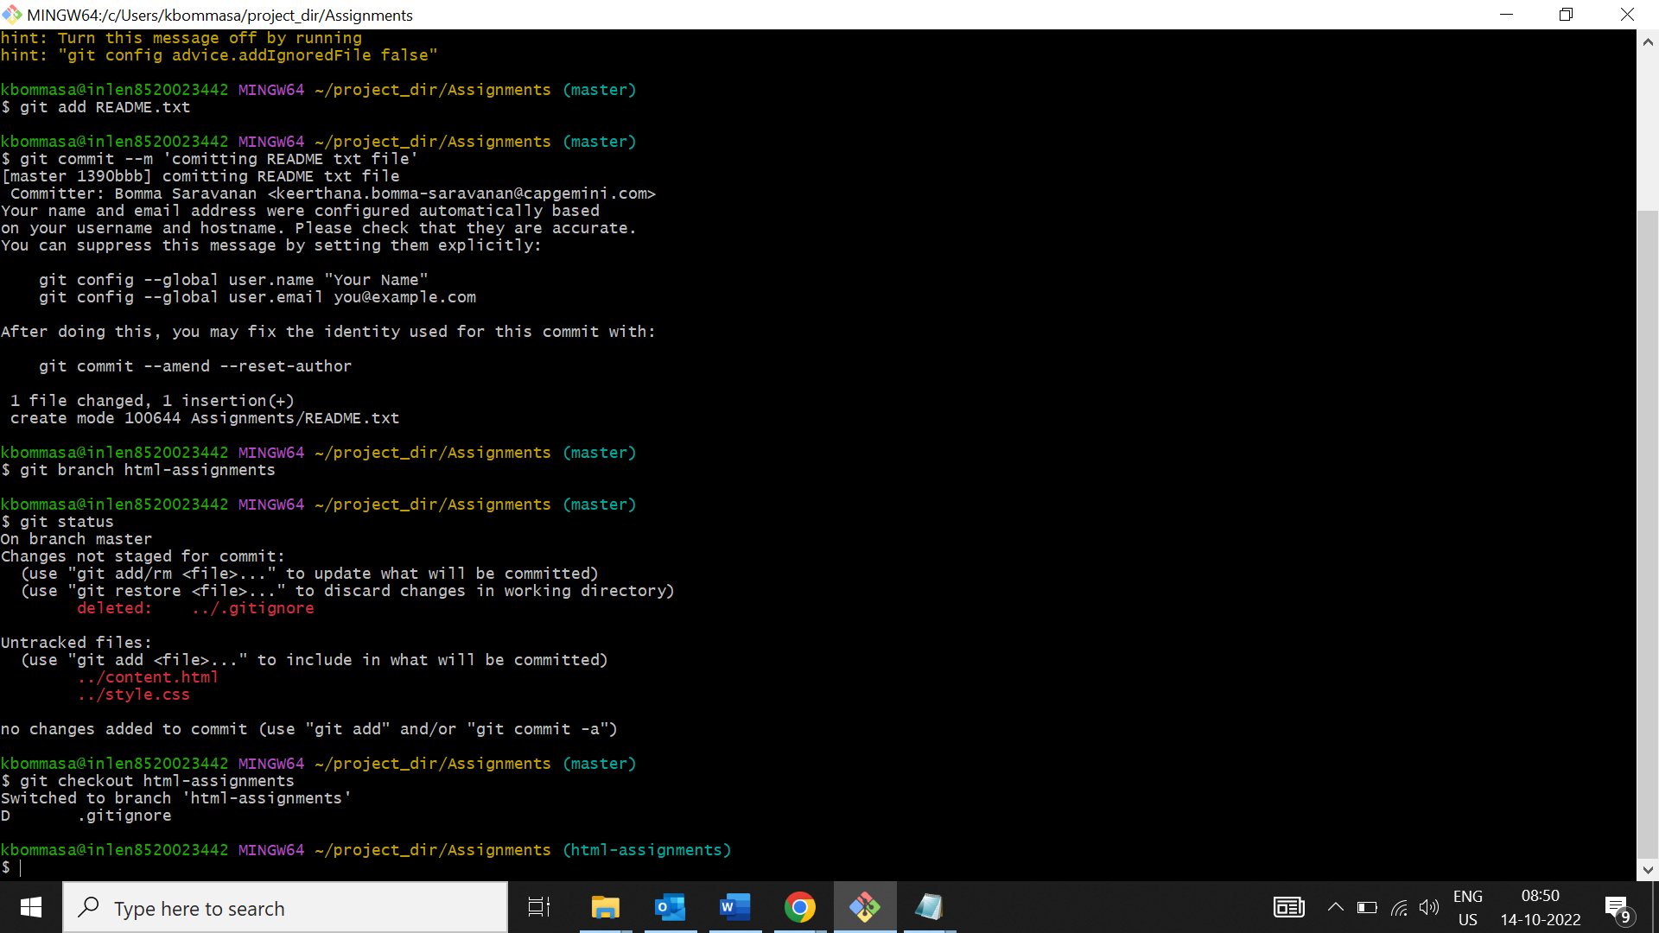  
27.copy all html-assignments inside assignments folder.

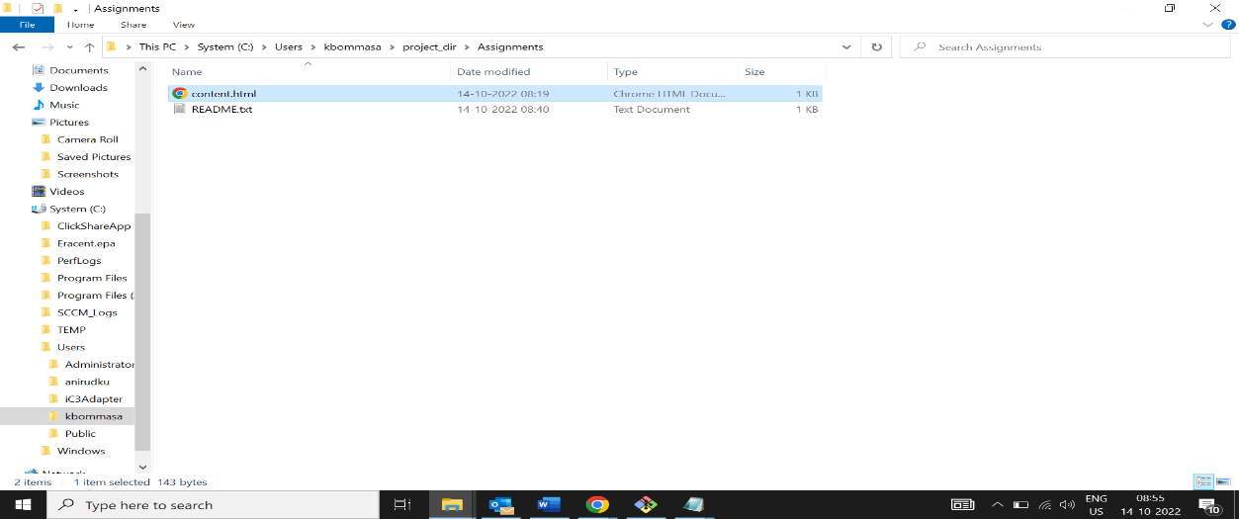

28.commit html assignment into html-assignments branch

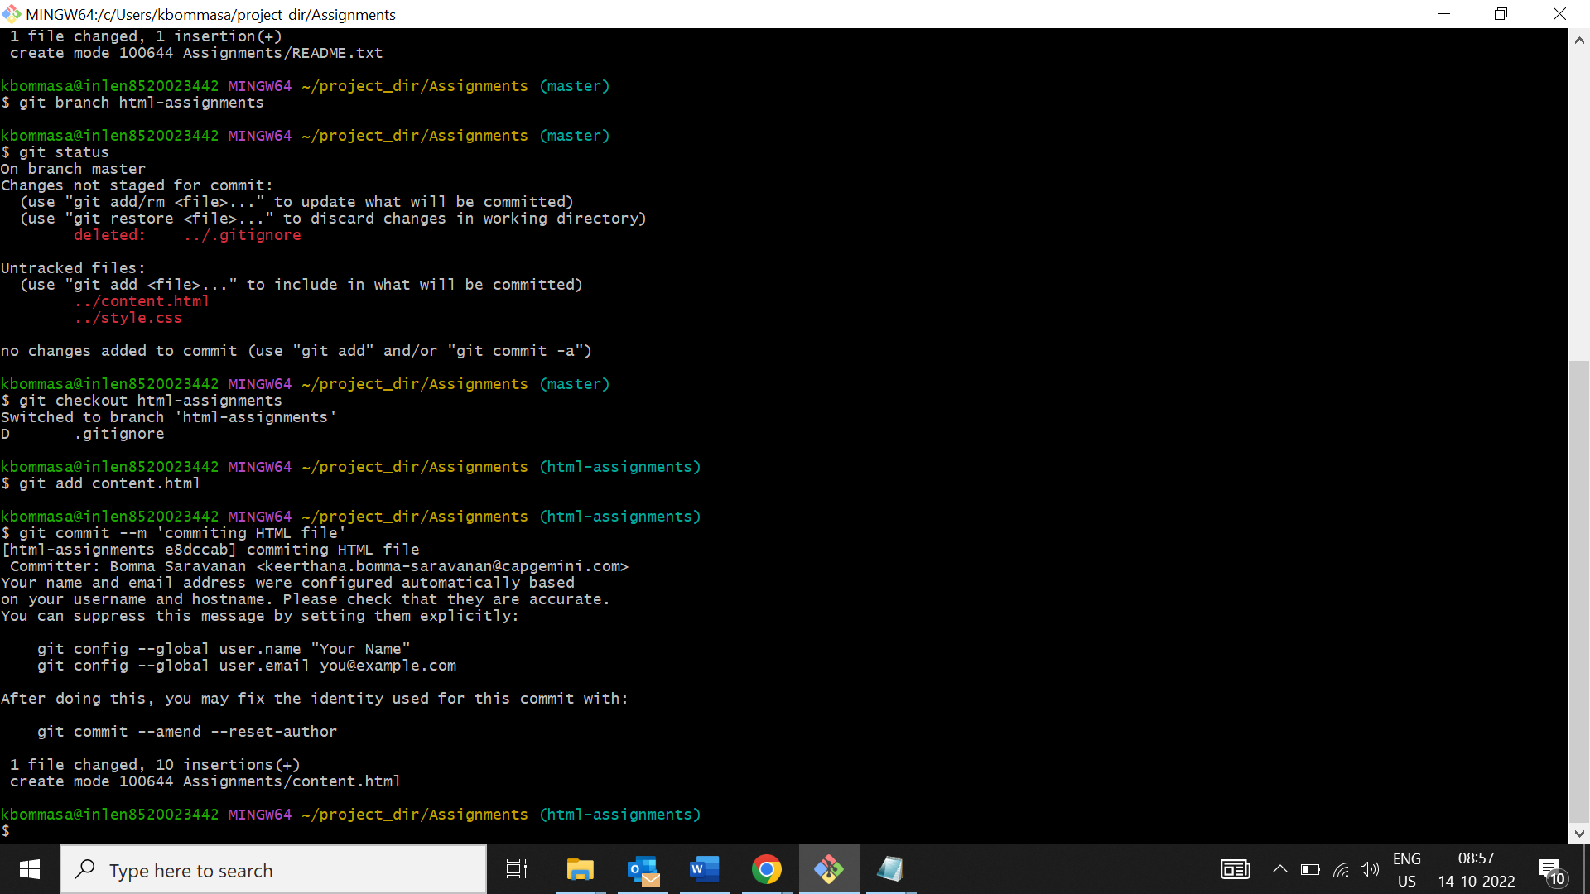

29.Make minor changes in the few files belonging to html-assignments branch.

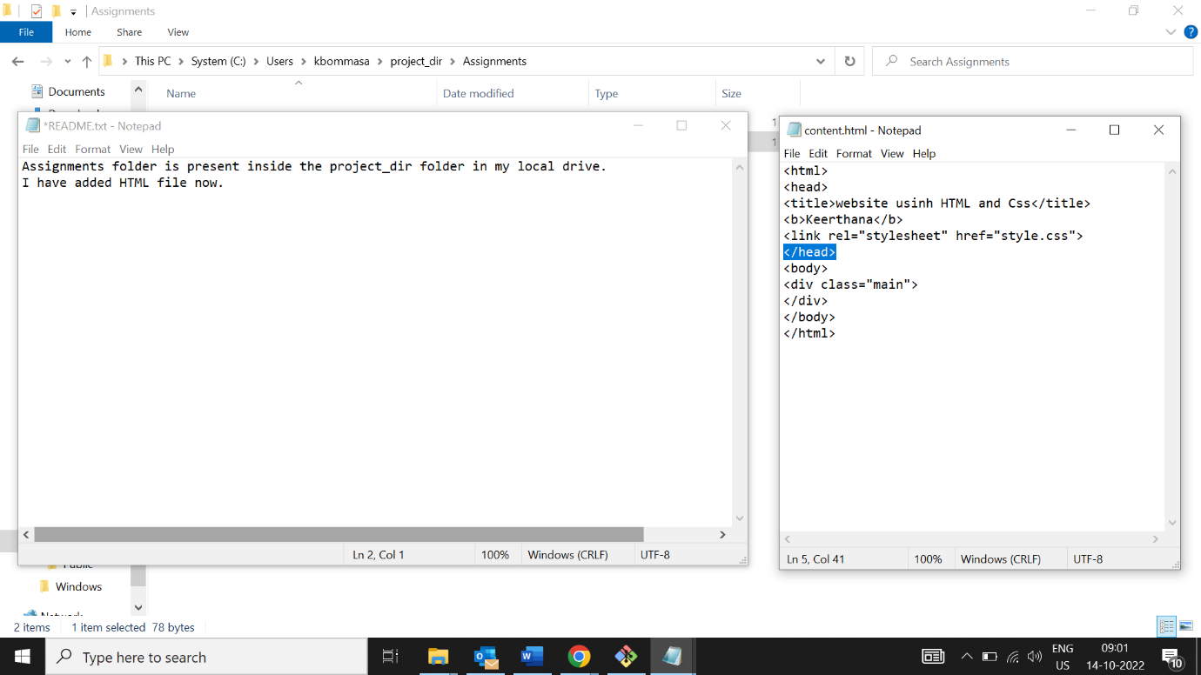

30.commit those changed files.

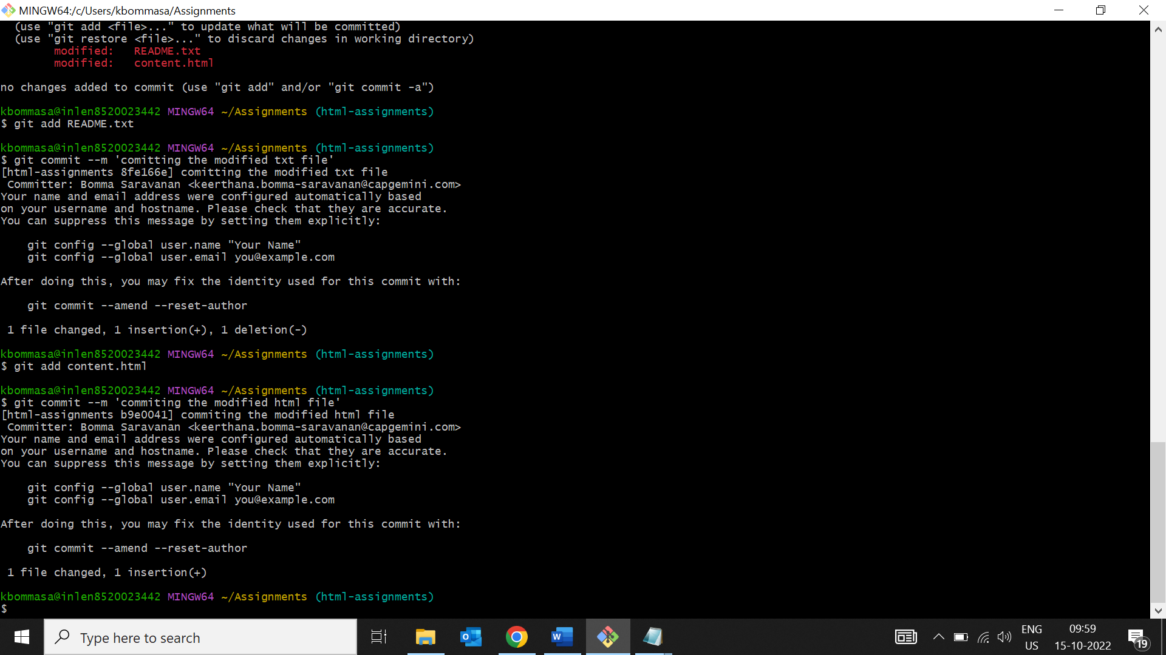

31.switch to master branch.

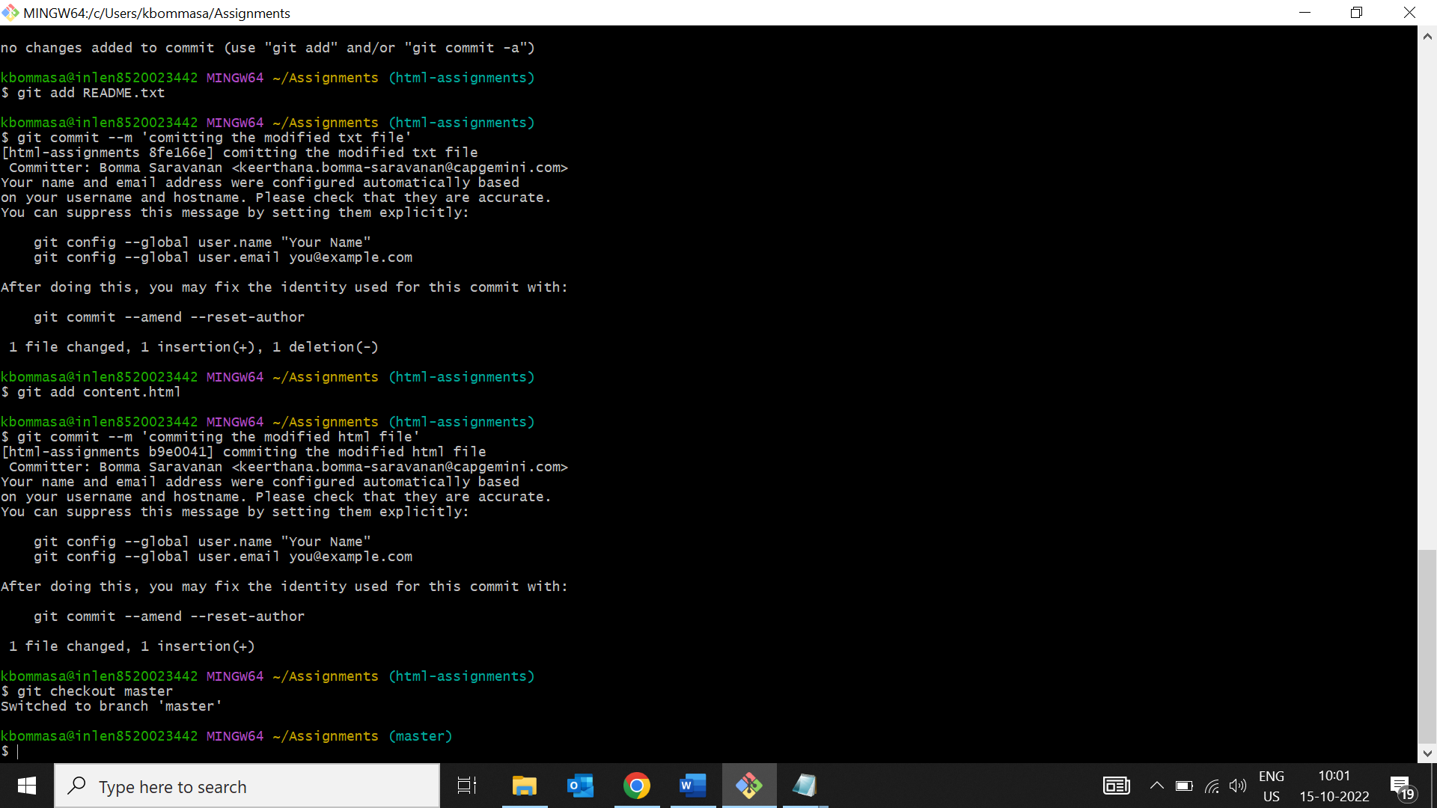

32.Make minor changes to README.txt file and commit to master branch

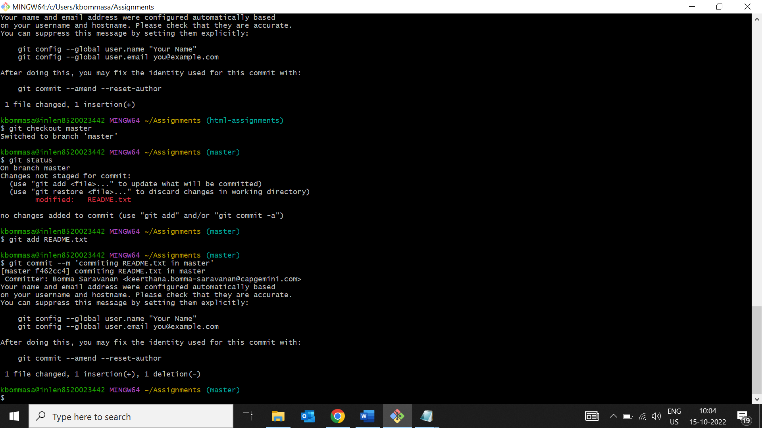

33.Again switch to html-assignments branch.

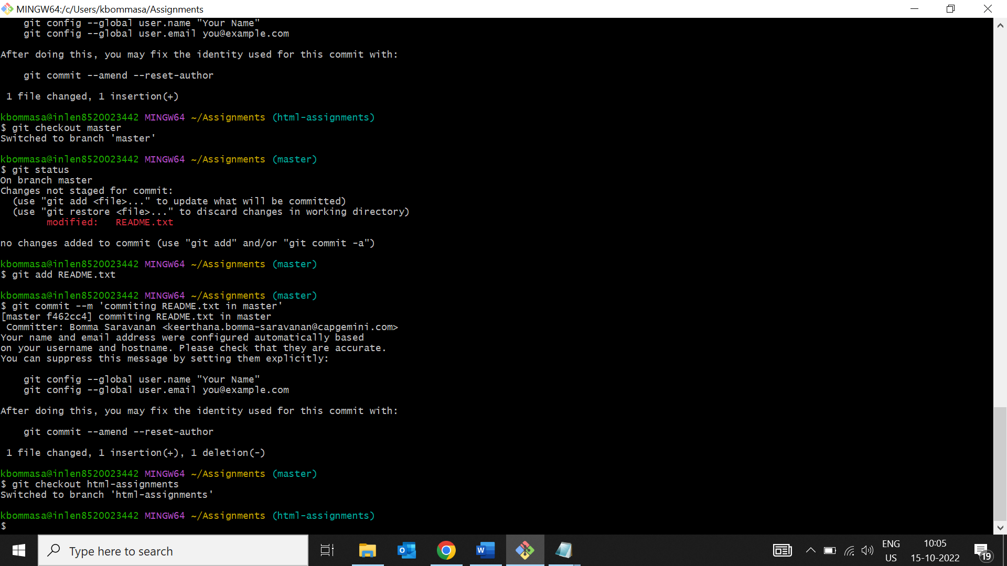

34.Make minor changes into few files belonging to html-assignment branch.

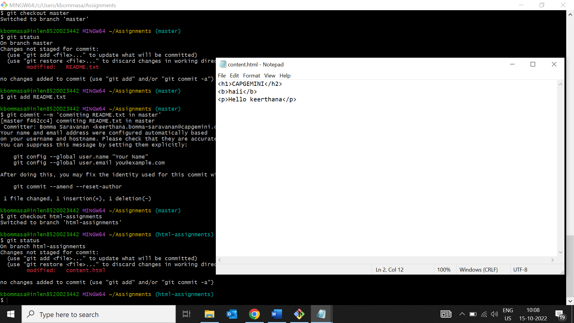

35.commit those changes.

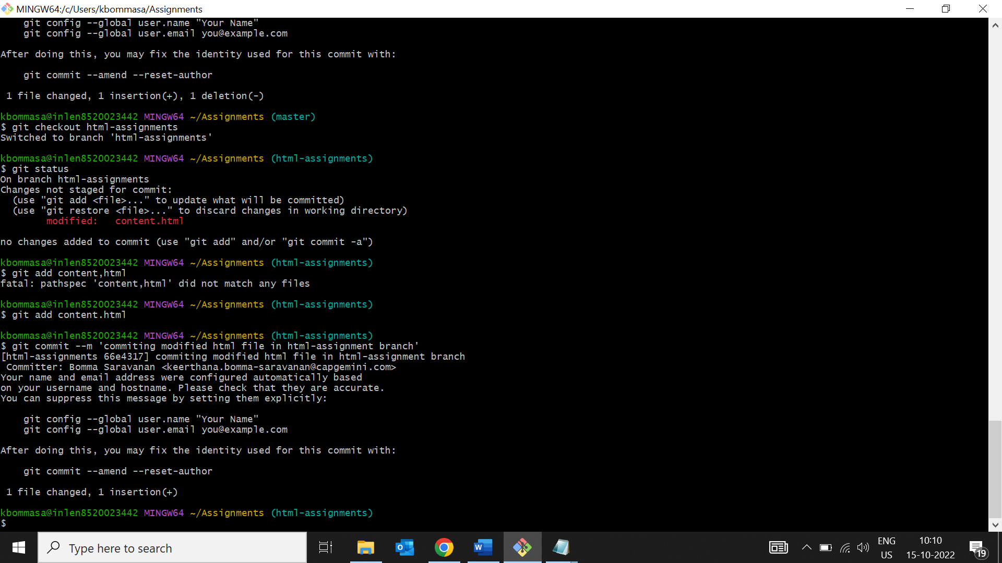

36.switch to master.

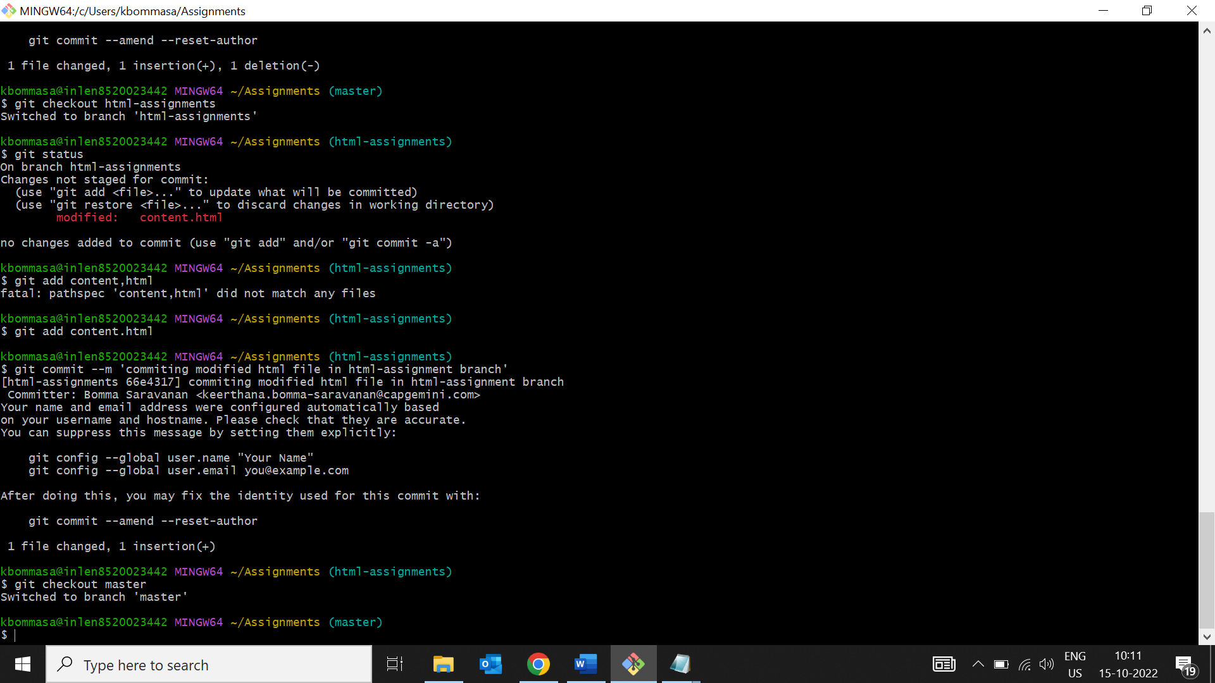

37.Merge html assignments in master and confirm all html assignments are shown in master.

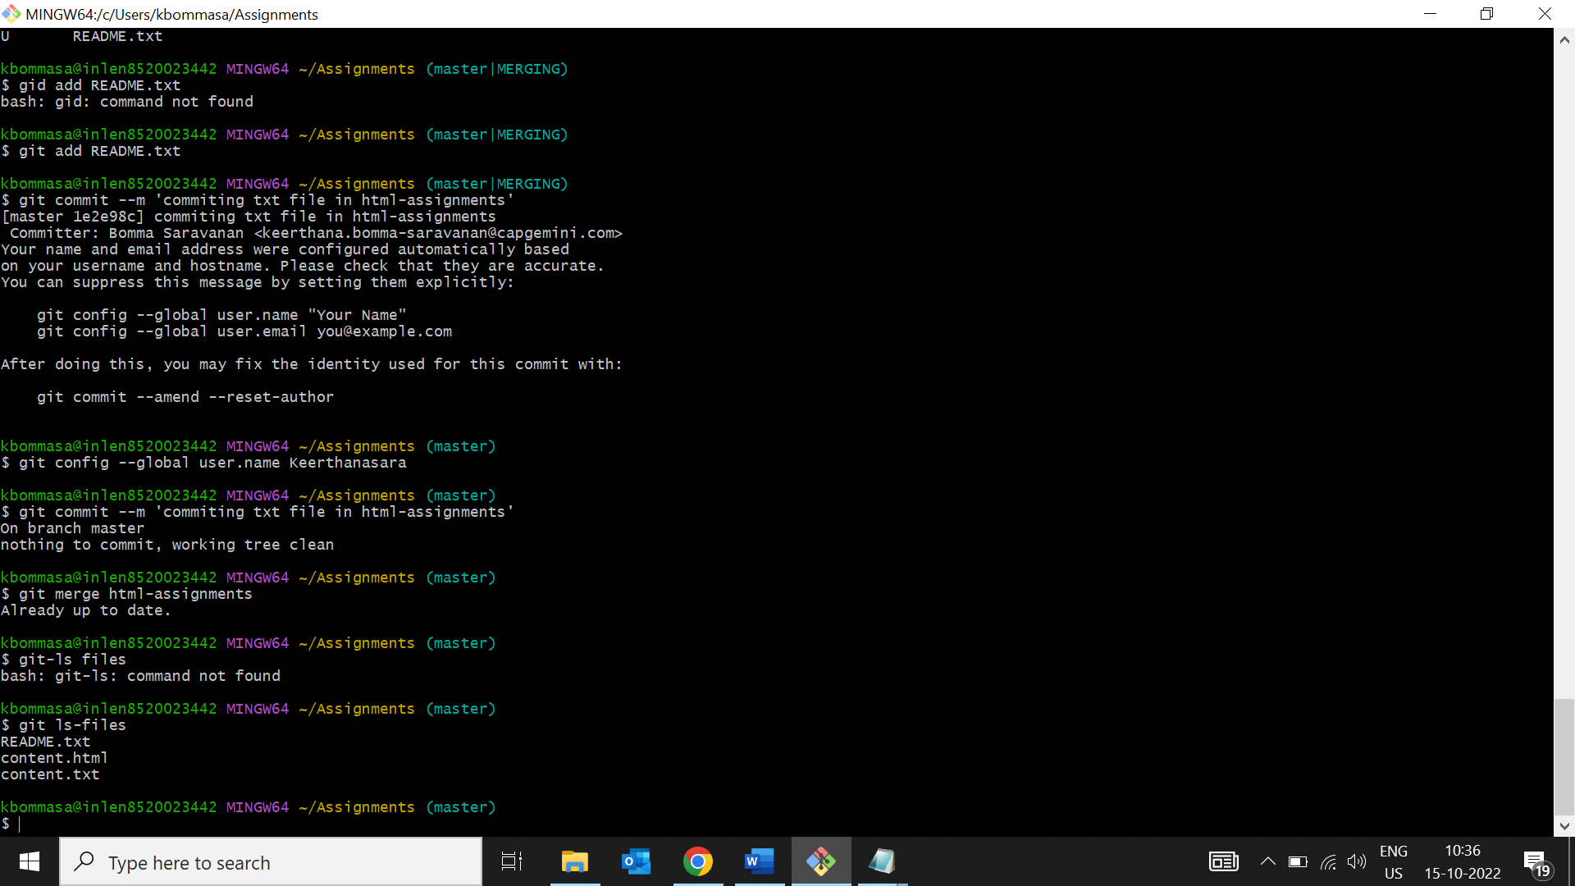

38.Finally delete the html branch

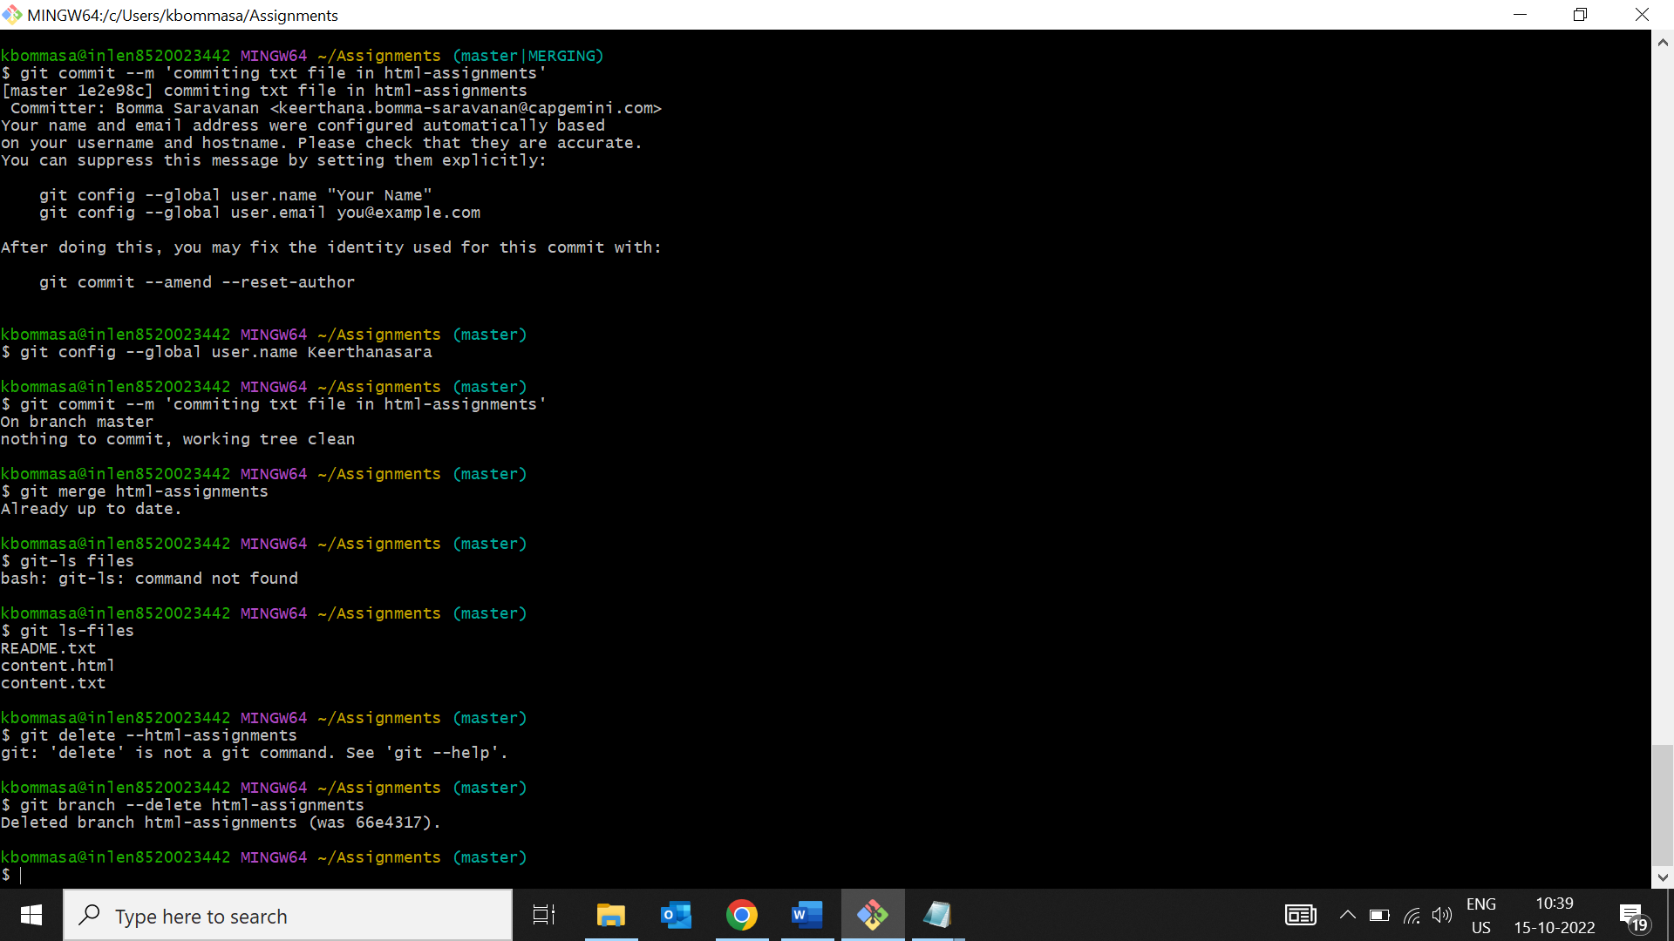

**Section-2 CSS ASSIGNMENTS**

1.create a new branch css-assignments

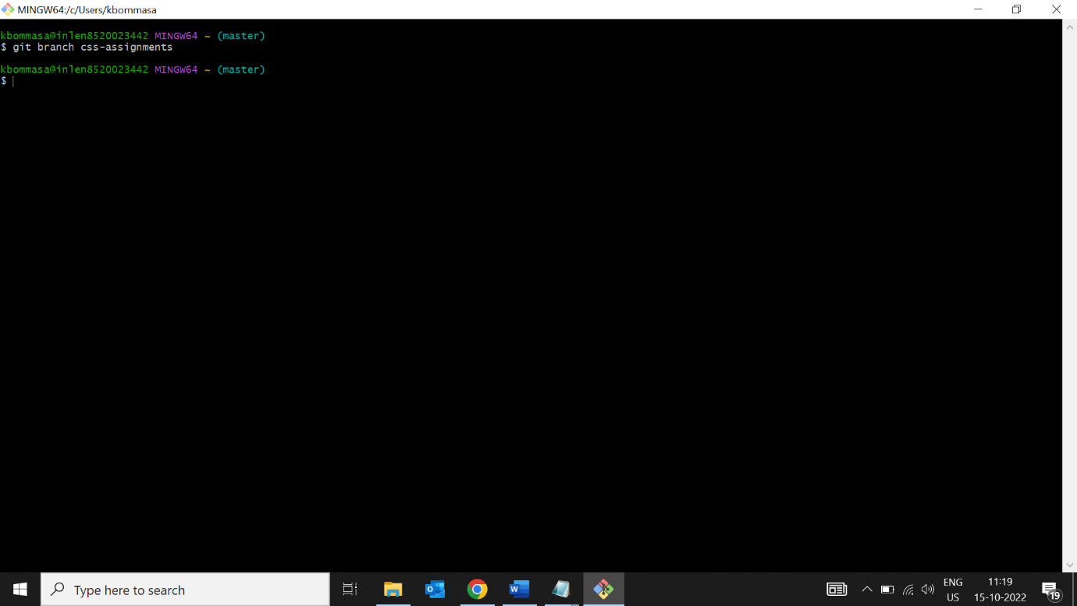

2.switch to css-assignments branch

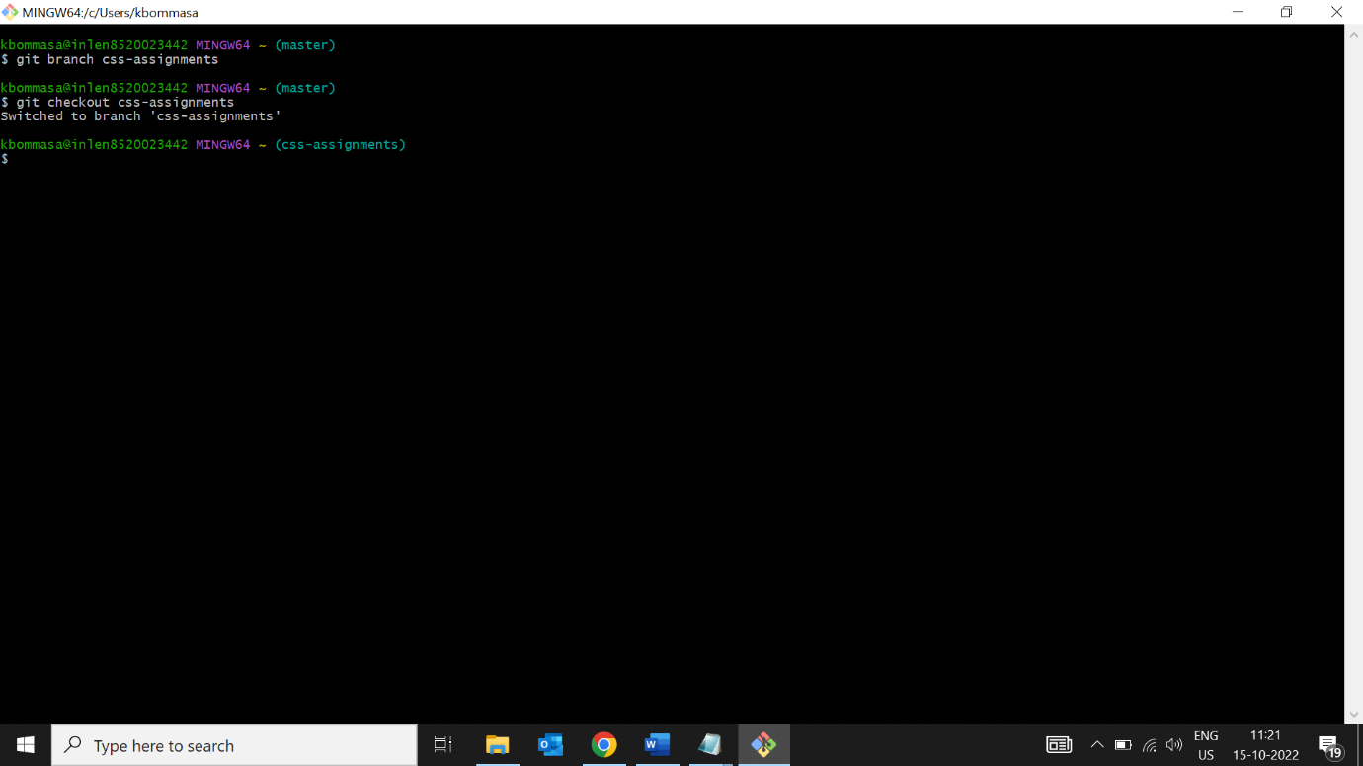

3.copy all css assignments into css-assignments branch.

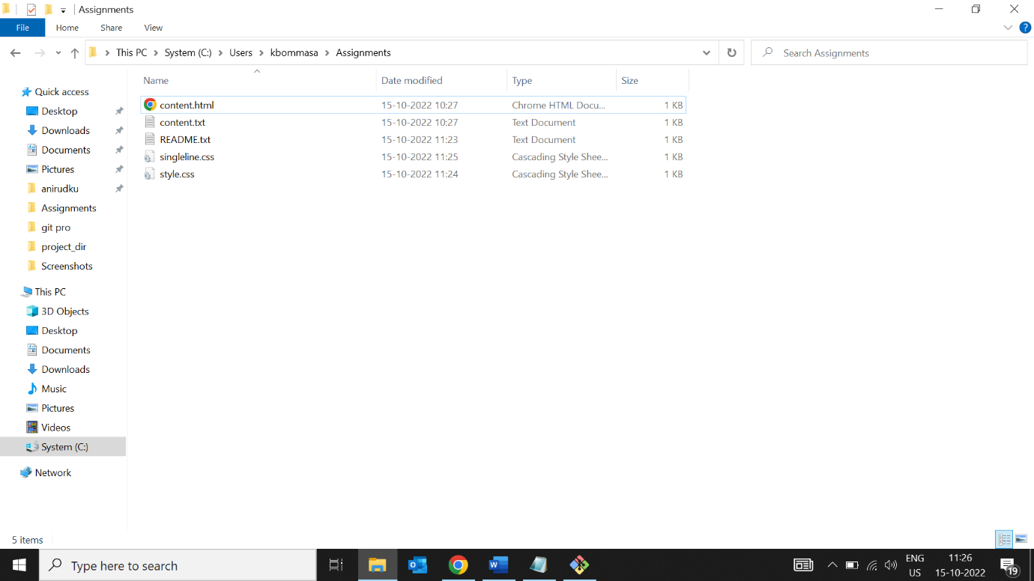

4.commit css assignments into css assignments branch.

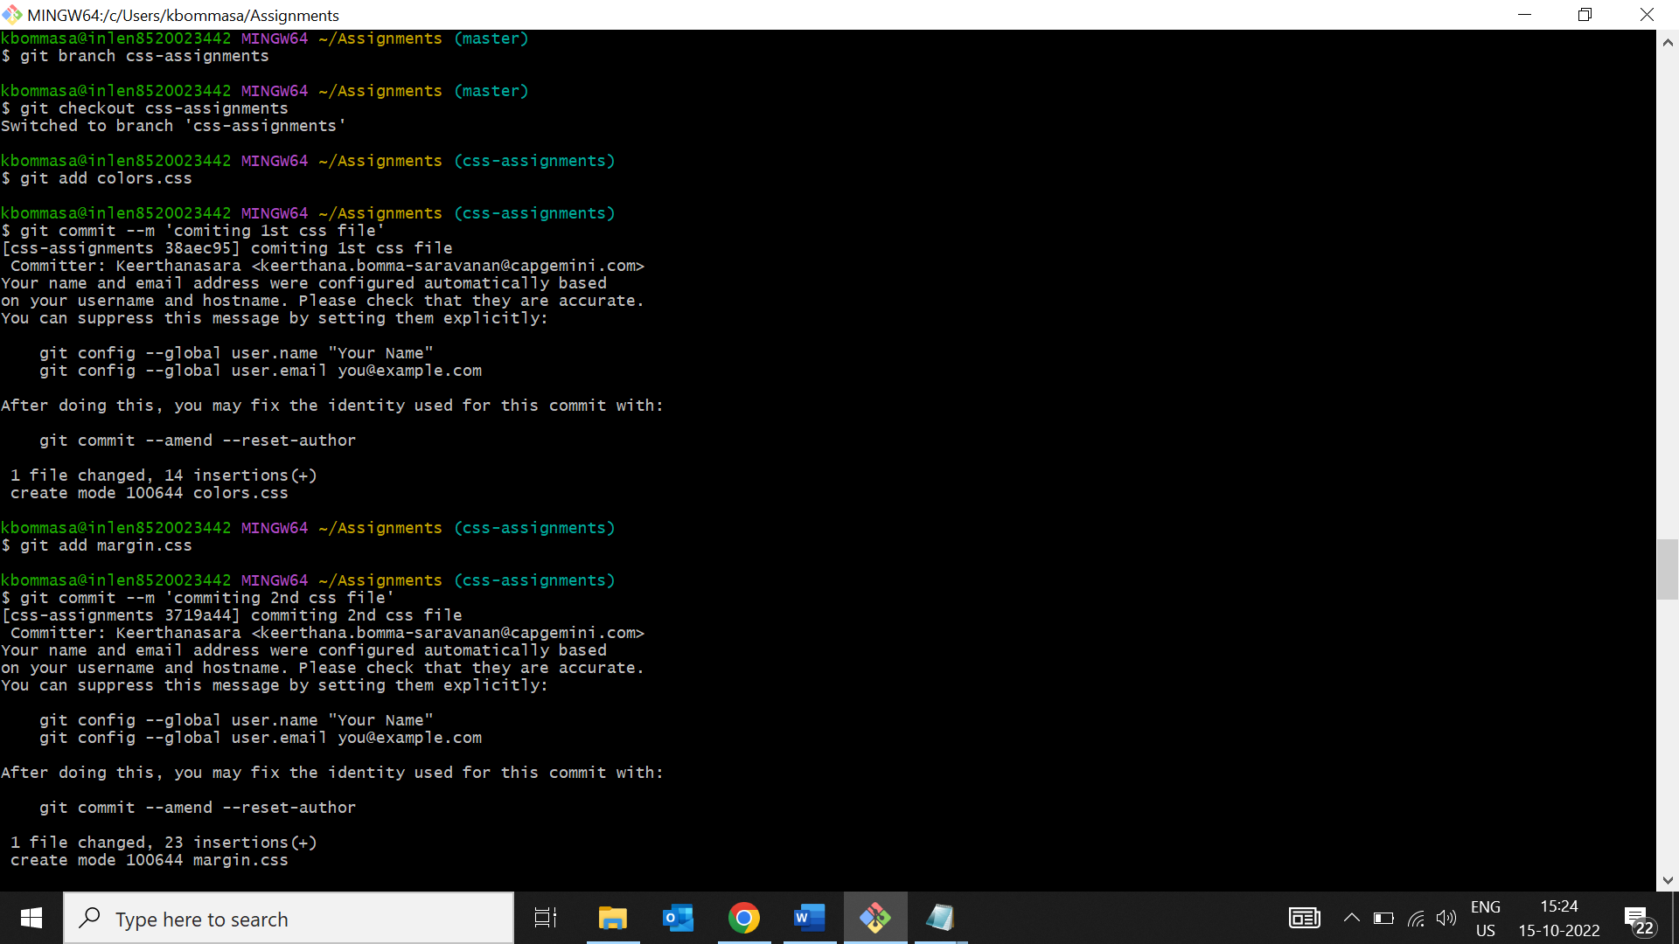

5. Make minor changes into README.txt file on line 1 belonging to ‘css-assignments’ branch.

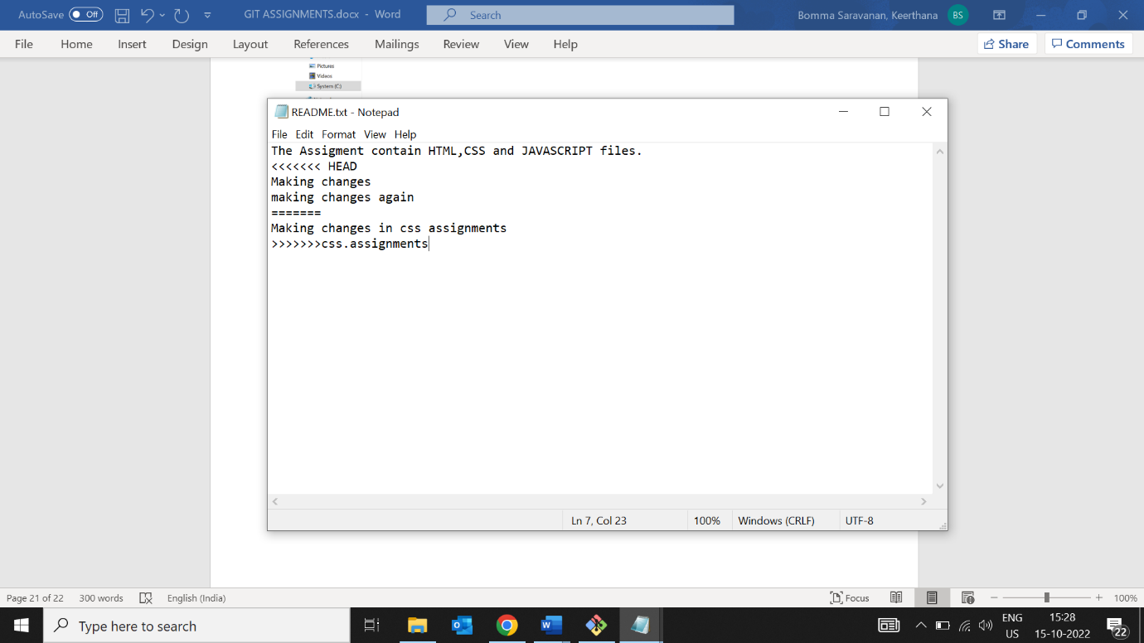

6.Commit those changed files.

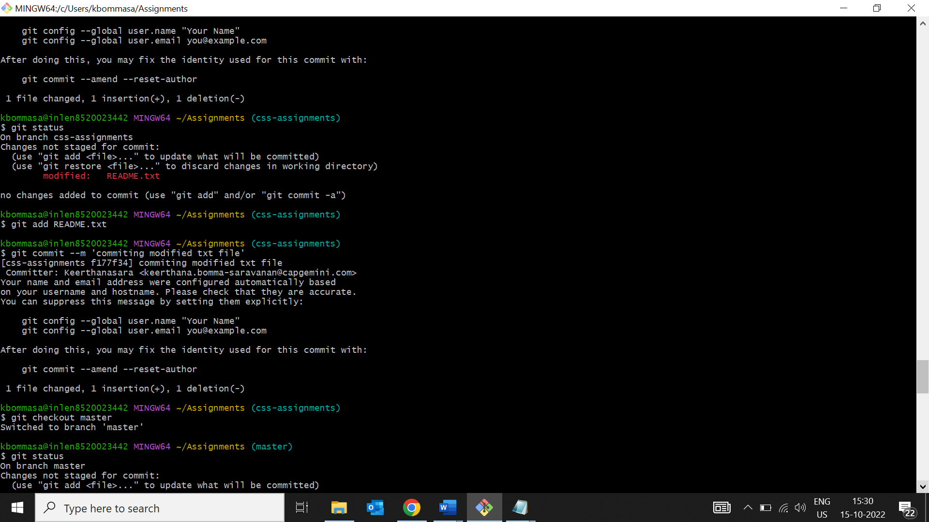

7. Switch to master branch.

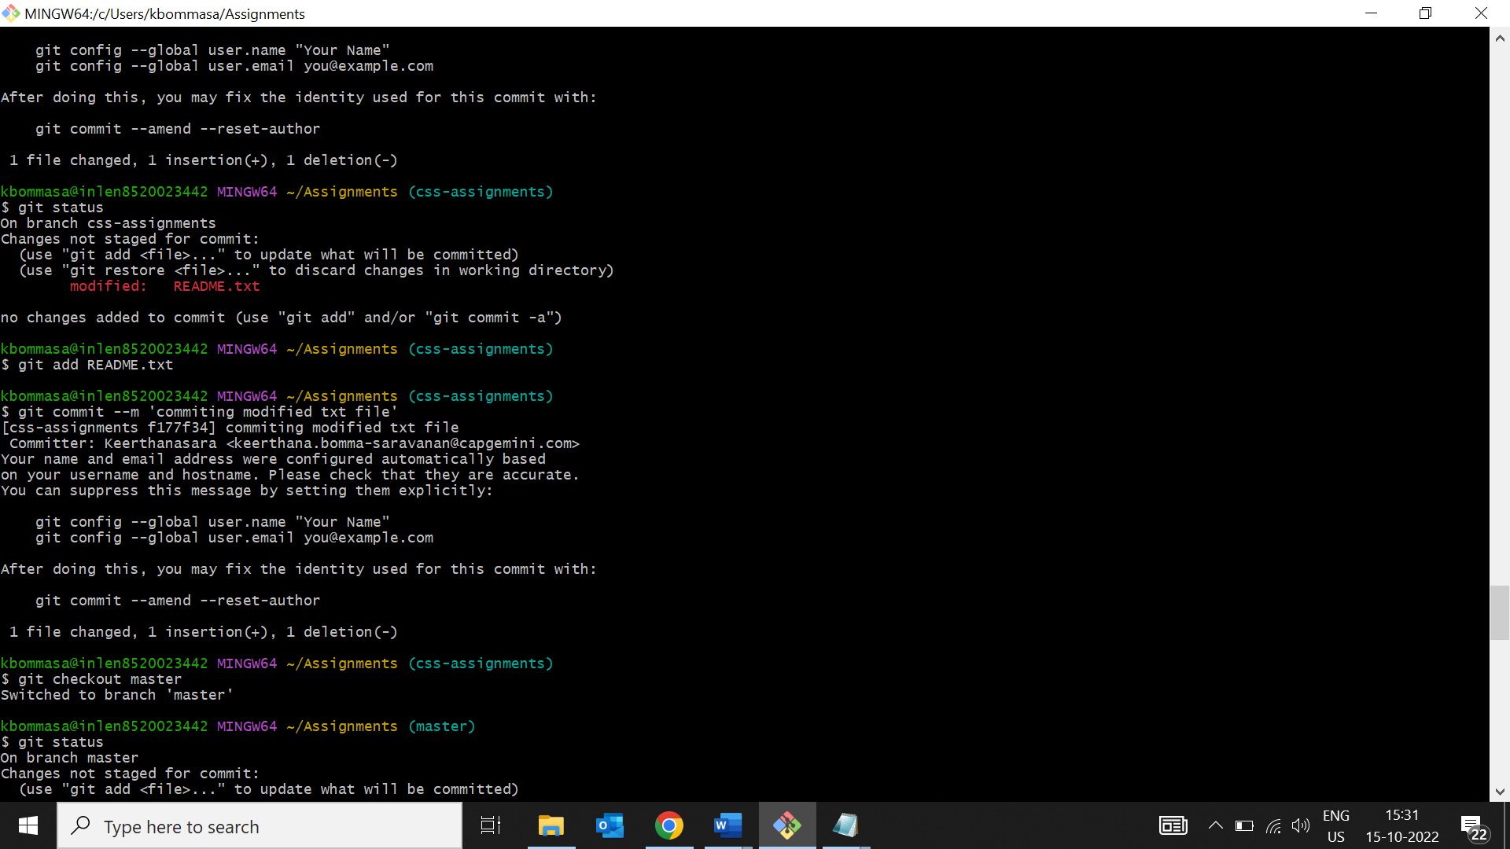

8. Make minor changes into README.txt file on line 3 & commit those changes into master.

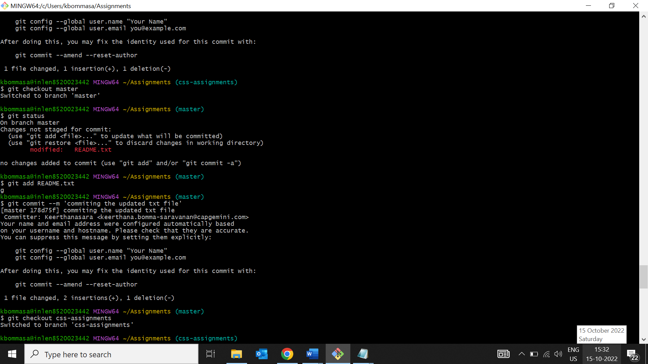

9. Again switch to ‘css-assignments’ branch.

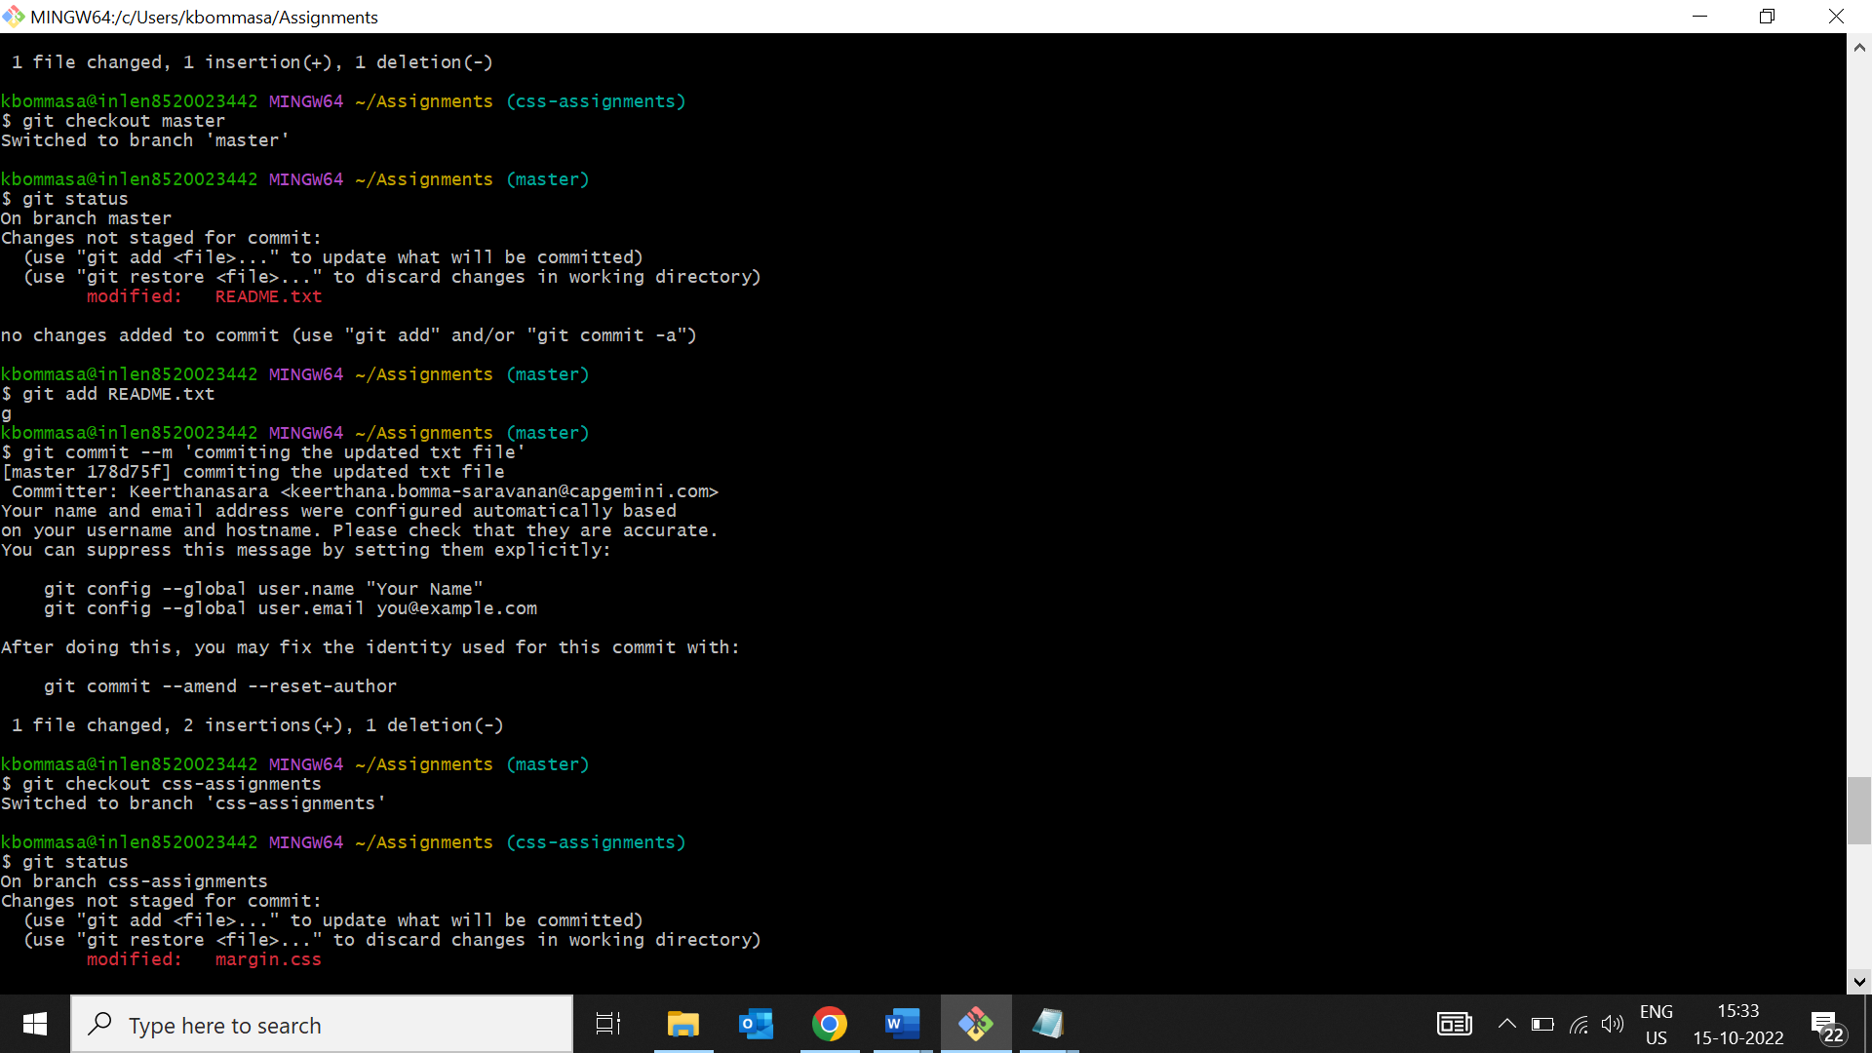

10. Make minor changes into few files belonging to ‘css-assignments’ branch.

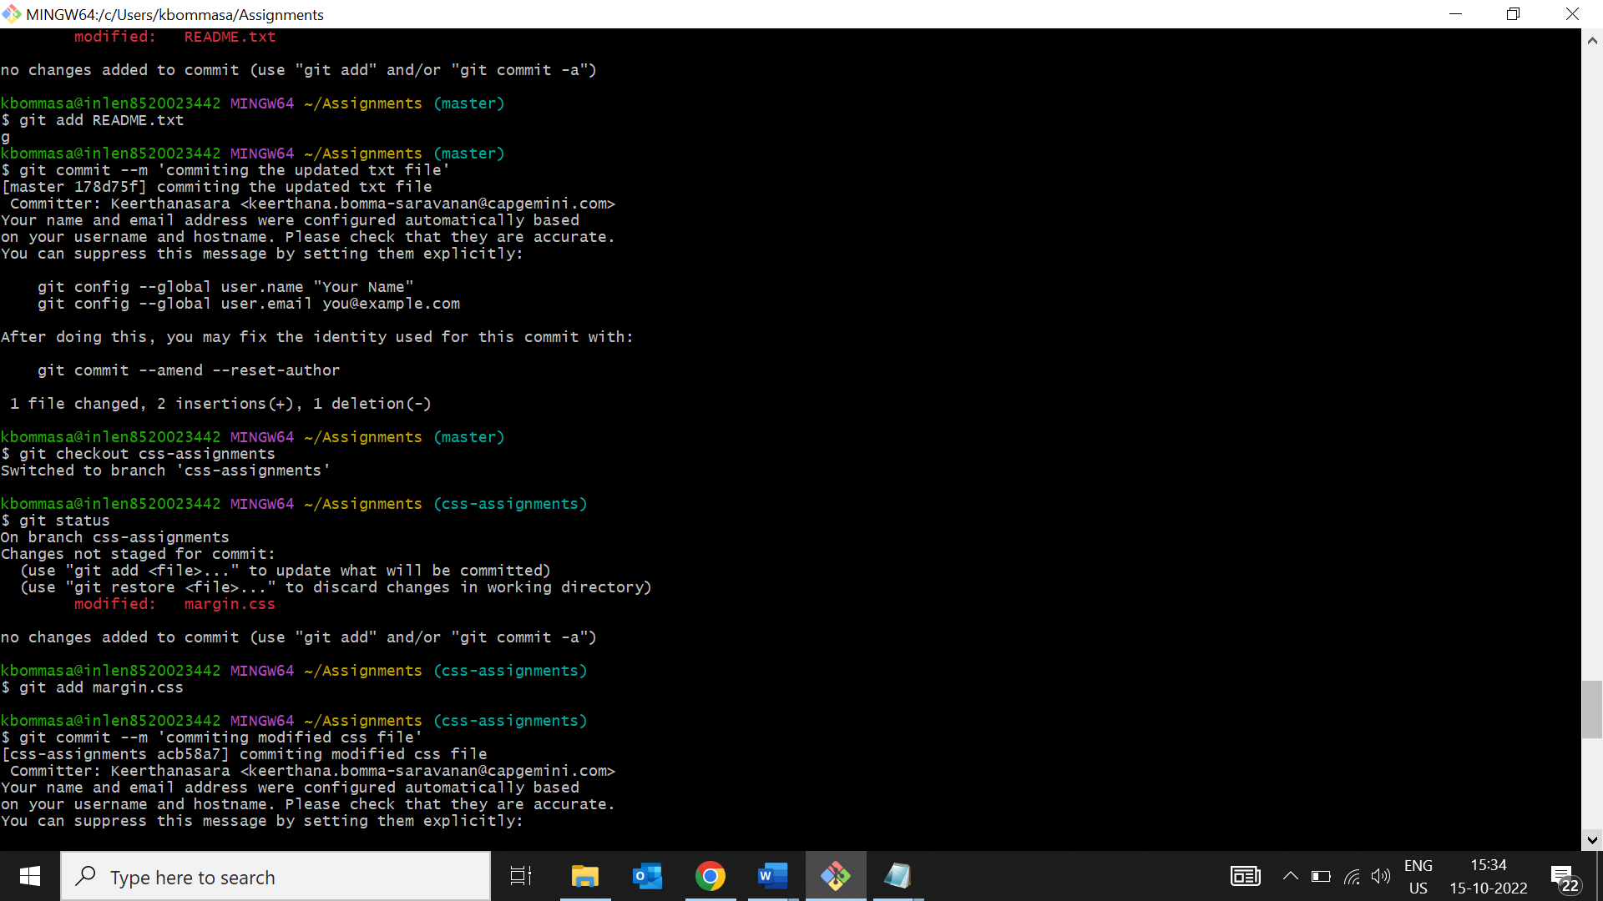

11. Commit those changes.

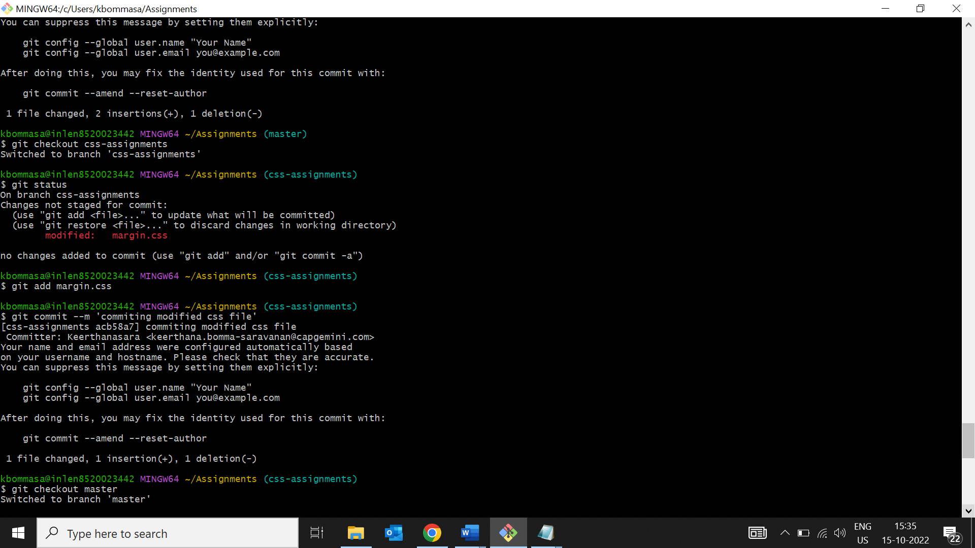

12. Switch to master.

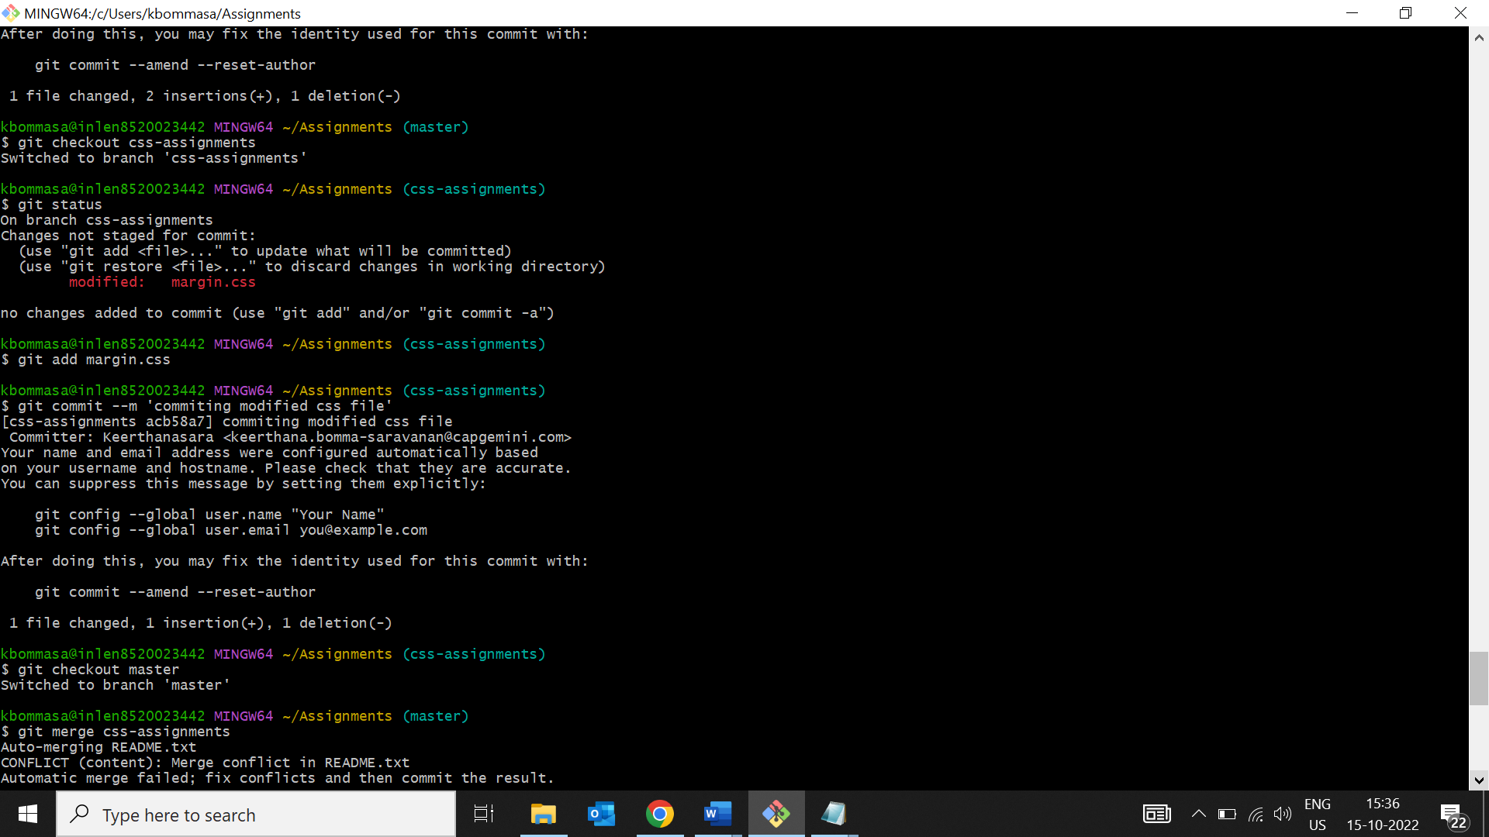

13. Merge ‘css-assignments’ branch into master. Confirm all css assignments are shown in master.

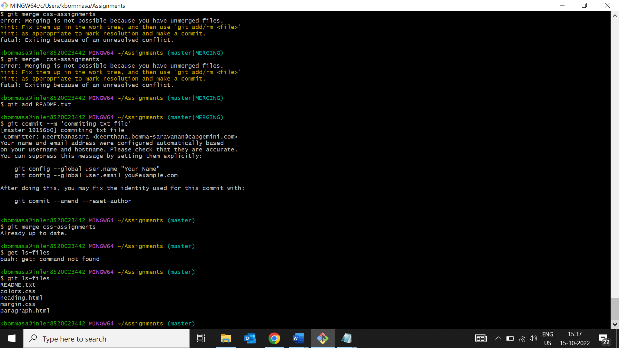

14. Finally delete the ‘css-assignments’ branch

